**Determining the Planck constant using LEDs**

Introduction

This experiment should be attempted after candidates have studied the photoelectric effect. Students also need to be able to set up a d.c. circuit and make measurements of potential difference (p.d.).

Students will use their practical skills of measuring and recording numerical data, plotting a interpreting the gradient to obtain a numerical solution to the problem given.

**Aims and skills covered**

* To determine a value for the Planck constant

Links to Specification

**Physics A**

* 4.5.1(a)(b)(c)(d)(e) Photons, Planck constant and energy eV

**Physics B**

* 4.1a(vi) evidence that photons exchange energy in quanta *E = hf*
* 4.1c(iv) the energy carried by photons across the spectrum *E = hf*

Practical Skills

* 1.2.1(b) safely and correctly use a range of practical equipment and materials
* 1.2.1(c) follow written instructions
* 1.2.1(d) make and record measurements and observations
* 1.2.1(e) keep appropriate records of experimental activities
* 1.2.1(f) present information and data in a scientific way
* 1.2.1(h) use online and offline research skills
* 1.2.1(i) correctly cite sources of information
* 1.2.1(j) use a wide range of equipment and techniques
* 1.2.2(b) use appropriate digital meters to measure the p.d. across a light emitting diode at the point of conduction
* 1.2.2(c) use methods to increase accuracy of measurements
* 1.2.2(f) correctly construct circuits from circuit diagrams including components where polarity is important

**CPAC**

* (1) Follows written procedures
* (3) Safely uses a range of practical equipment and materials
* (4) Makes and records observations
* (5) Researches, references and reports

**Mathematical skills**

* M0.1 recognise and make use of appropriate units in calculations
* M0.2 recognise and use expressions in decimal and standard form
* M1.1 use an appropriate number of significant figures
* M1.2 find arithmetic means
* M2.2 change the subject of an equation
* M2.3 substitute numerical values into algebraic equations
* M3.1 translate information between graphical numerical numerical and algebraic forms
* M3.2 plot two variables from experimental or other data
* M3.3 understand that *y* = *mx* + *c* represents a linear relationship
* M3.4 determine the slope of a linear graph

Equipment (per group):

* a variety of different coloured light-emitting diodes of known frequency or wavelength
* 7 connecting leads
* two cells or power supply set at 3V
* rheostat to be used as a potentiometer
* digital voltmeter
* 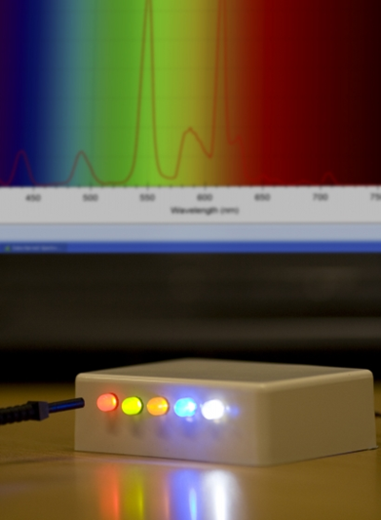card or black paper

A variety of LEDs should be available. These should be labelled with their wavelengths clearly displayed, for example mounting each LED on a component holder with the information on a label stuck to the component holder.

A series resistor in the circuit can reduce the likelihood of damaging the LED with excessive current.

If the manufacturer of the LED is unable to give details of designed wavelength, a spectrum analyser (such as the Data-Harvest Spectrometer reference 3310) can be used to identify the operating wavelength.

Some very good equipment is available to aid this experiment such as the Lascells Planck Constant S600-002 Laboratory LED Apparatus.

**Health and safety**

* PS52 “*Lasers, Laser Devices and LEDs (revised 2013)”* identifies issues with the intensity and focussed nature of the beam of some LEDs. Learners should not look directly at the focussed beam of LEDs at full intensity. Also note that blue LEDs can be hazardous.

Before carrying out any experiment or demonstration based on this guidance, it is the responsibility of teachers to ensure that they have undertaken a risk assessment in accordance with their employer’s requirements, making use of up-to-date information and taking account of their own particular circumstances. Any local rules or restrictions issued by the employer must always be followed.

**Notes**

* These practical activities are not controlled assessments, should not be carried out in exam conditions and can be adapted by the centre. Students can collaborate during the activities which should take place as part of the normal teaching sequence. They are intended to be formative with students acquiring and practising skills throughout the course.
* To achieve a pass in the Practical Endorsement each student is required to demonstrate competence in all the skills, apparatus and techniques listed in section 1.2 of the specification and assessed against the Ofqual Common Practical Assessment Criteria (CPAC) at the end of the course.
* The skills, apparatus and techniques can be demonstrated during any practical work undertaken during the A Level course whether an OCR practical activity or not.
* Some LEDs which are supplied ready mounted on component holders have a current limiting resistor already fitted. Connecting a voltmeter across the component holder will give an erroneous reading of potential difference, including that of the resistor as well as the LED. Either use a crocodile clip to access the connection directly to the LED or make some other connection available to the students.
* If using separate components a suitable protective resistor should be fitted in series with the LED to avoid damaging the components with excessive current.
* The card or black paper allows a tube to be constructed to eliminate ambient light and allow more precise identification of the turn on voltage of the LED.
* The camera on some mobile phones is sensitive to infra-red or ultra-violet, which allows students to extend the range of wavelengths with appropriate LEDs.

**Recording**

* Learners should not need to re-draft their work but rather keep all their notes as a continuing record of Practical Activity.
* As evidence for the Practical Endorsement learners should have the measurements collected in a clear and logical format.

In addition, to support the assessment of practical work in the written examinations:

* Learners should have commented on the accuracy of their result including researched value with citation.
* Learners should have drawn conclusions consistent with the evidence obtained.