|  |
| --- |
| * O C E / 1 7 4 6 8 * |



**ADVANCED SUBSIDIARY GCE**



|  |  |
| --- | --- |
| **PHYSICS A** | **G482** |
| Electrons, Waves and Photons |  |

|  |  |  |
| --- | --- | --- |
| Candidates answer on the Question Paper | **Monday 17 January 2011** |  |
| **Afternoon** |  |
| **OCR Supplied Materials:** |  |
|  |  |
| • Data, Formulae and Relationships Booklet | **Duration:** 1 hour 45 minutes |  |
|  |  |

**Other Materials Required:**

* Electronic calculator

* G 4 8 2 *



**INSTRUCTIONS TO CANDIDATES**

* Write your name clearly in capital letters, your Centre Number and Candidate Number in the boxes above.
* Use black ink. Pencil may be used for graphs and diagrams only.
* Read each question carefully and make sure that you know what you have to do before starting your answer.
* Answer **all** the questions.
* Do **not** write in the bar codes.
* Write your answer to each question in the space provided. If additional space is required, you should use the lined pages at the end of this booklet. The question number(s) must be clearly shown.

**INFORMATION FOR CANDIDATES**

* The number of marks is given in brackets **[ ]** at the end of each question or part question.
* The total number of marks for this paper is **100**.
* You may use an electronic calculator.
* You are advised to show all the steps in any calculations.

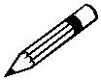

• Where you see this icon you will be awarded marks for the quality of written communication

in your answer.

This means for example you should:

* + ensure that text is legible and that spelling, punctuation and grammar are accurate so that meaning is clear;
  + organise information clearly and coherently, using specialist vocabulary when appropriate.
* This document consists of **20** pages. Any blank pages are indicated.

© OCR 2011 [L/500/8055] OCR is an exempt Charity

DC (SHW 00491 5/09) 17468/8 **Turn over**

**2**

Answer **all** the questions.

1. A resistor **X** is constructed from a rod of cross-sectional area 9.0  10–6 m2 and length 0.012 m as shown in Fig. 1.1. The resistivity of the material of the rod is 2.4 _ m.

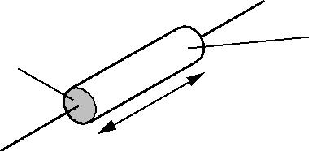

resistor **X**

9.0 × 10–6 m2

0.012 m

**Fig. 1.1**

**(a)** Show that the resistance of the resistor **X** is 3.2 k_.

**[2]**

1. The power rating of resistor **X** is 0.125 W. Show that the maximum potential difference which should be applied safely across the resistor is 20 V.

**[2]**

1. A student needs a resistor of the same resistance as **X** but with a power rating of 0.50 W. The only resistors available are identical to **X**. It is suggested that four of these resistors could be connected as shown in Fig. 1.2 to solve the problem. The potential difference across the combination of resistors is 40 V.

|  |  |  |  |  |  |  |  |  |  |
| --- | --- | --- | --- | --- | --- | --- | --- | --- | --- |
|  |  |  | **X** |  | **X** |  |  |  |  |
|  |  |  |  |  |  |  |  |  |  |
|  |  |  |  |  |  |  |  |  |  |
|  |  |  | **X** |  | **X** |  |  |  |  |
|  |  |  |  |  |  |  |  |
|  |  |  |  |  |  |  |  |  |  |
|  |  |  |  |  |  |  |  |  |  |
|  |  |  |  |  | |  |  |  |  |
|  |  |  |  | 40V | |  |  |  |  |
|  |  |  |  | **Fig. 1.2** | |  |  |  |  |



© OCR 2011

**3**

**(i)** Show that the total resistance of the combination in Fig. 1.2 is 3.2 k_.

**[2]**

1. Show that the power dissipation in each resistor is 0.125 W.

...........................................................................................................................................

...........................................................................................................................................

...........................................................................................................................................

.................................................................................................................................... **[2]**

1. Another resistor **Y** is constructed from the same material but has twice the length and twice the diameter of resistor **X**.
   1. Show that the resistance *R*Y of **Y** is half the resistance *R*X of resistor **X**.

**[2]**

1. The two resistors **X** and **Y**, where *R*Y = *R*X/2, are connected in series to a d.c. power supply as shown in Fig. 1.3.

d.c. supply

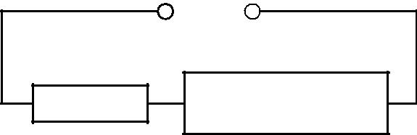

**X**

**Y**

**Fig. 1.3**

State and explain which resistor dissipates greater power.

...........................................................................................................................................

...........................................................................................................................................

...........................................................................................................................................

...........................................................................................................................................

.................................................................................................................................... **[3]**

**[Total: 13]**

© OCR 2011

**Turn over**

**4**

1. **(a)** A 12 V car battery contains an electrolyte. The battery is connected to an electric motor **M**.There is a current in the motor and the battery. See Fig. 2.1.

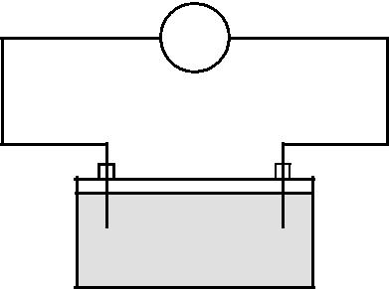

**M**

* –

 battery

electrolyte

**Fig. 2.1**

State

1. the charge carriers in the electrolyte

.................................................................................................................................... **[1]**

1. the charge carriers moving through the electrolyte to the positive terminal of the battery

.................................................................................................................................... **[1]**

1. the charge carriers moving through the wires to the positive terminal of the battery.

.................................................................................................................................... **[1]**

**(b)** When used to start the engine of the car, the electric motor draws 40 A from the battery of e.m.f. 12 V. The potential difference across the motor at this time is only 8.0 V.

1. Explain why the potential difference across the motor at this time is not the same as the e.m.f. of the car battery.

...........................................................................................................................................

...........................................................................................................................................

...........................................................................................................................................

.................................................................................................................................... **[2]**

**(ii)** Show that the internal resistance of the battery is 0.10 _.

**[3]**

© OCR 2011

**5**

1. It takes 1.2 s for the electric motor to start the engine. Calculate the charge *Q* which passes through the electric motor in this time.

*Q* = ..................................................... C**[2]**

1. The car has two 12 V headlamps each rated at 54 W, connected in parallel to the battery. In normal working conditions the current in each lamp is 4.5 A.
2. Explain how and why the resistance of the headlamp filament varies with the current passing through it.

...........................................................................................................................................

...........................................................................................................................................

...........................................................................................................................................

...........................................................................................................................................

.................................................................................................................................... **[2]**

1. Suggest a value for the current rating of a fuse for the headlamp circuit. Justify your choice.

...........................................................................................................................................

...........................................................................................................................................

.................................................................................................................................... **[2]**

1. A car contains a number of different fuses for its various electrical circuits. Suggest why this is necessary.

...........................................................................................................................................

...........................................................................................................................................

.................................................................................................................................... **[1]**

**[Total: 15]**

© OCR 2011

**Turn over**

**6**

1. **(a)** The following electrical quantities are often used when analysing circuits. Draw a straight linefrom each quantity on the left-hand side to its correct units on the right-hand side.

|  |  |
| --- | --- |
| potential difference | C s–1 |
| resistance | J C–1 |
| power | V A–1 |
| current | J s–1 |

**[3]**

1. Fig. 3.1 shows a battery of e.m.f. 6.0 V and negligible internal resistance connected in series with a thermistor and a 560 _ resistor.

6.0V

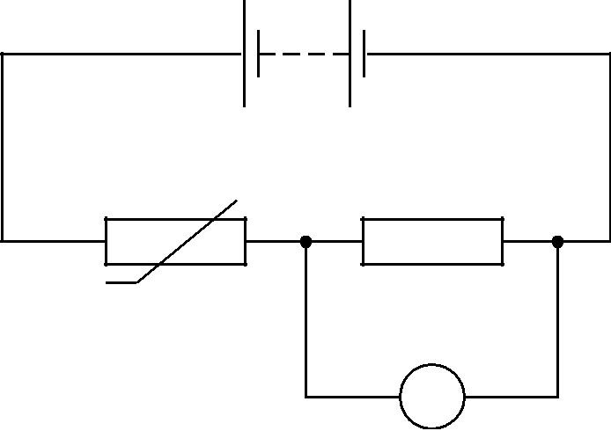

thermistor

560 X

V

**Fig. 3.1**

The voltmeter across the resistor has infinite resistance.

1. The reading on the voltmeter is 2.4 V. Calculate the resistance *R*T of the thermistor.

*R*T= ...................................................._**[3]**

1. Calculate the current in the circuit.

current = ..................................................... A **[1]**

© OCR 2011

**7**

1. The variation of resistance with temperature for this thermistor is shown in the graph of Fig. 3.2.

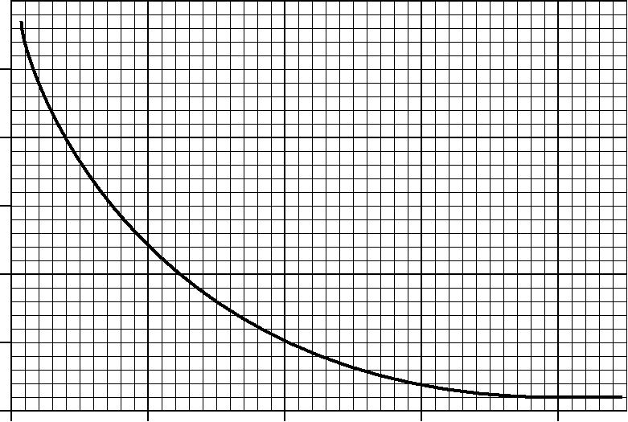

1000

resistance / X

800

600

400

200

0

0 50 100 150 200

temperature / C

**Fig. 3.2**

1. Use the graph to determine the temperature of the thermistor when its resistance is 800 _.

temperature = ................................................... °C **[1]**

1. State and explain, without calculation, how the reading of the voltmeter in Fig. 3.1 will change as the temperature of the thermistor increases to 80 °C.

...........................................................................................................................................

...........................................................................................................................................

...........................................................................................................................................

...........................................................................................................................................

.................................................................................................................................... **[3]**

© OCR 2011

**Turn over**

**8**

1. The circuit of Fig. 3.1 can be used as a temperature sensor. Temperature sensors are used in the kitchen to control the internal temperatures of ovens (typically 200 °C) and refrigerators (typically 4 °C). Use the graph of Fig. 3.2 to suggest in which device this sensor would be more suitable.



*In your answer you should link the information from the graph to the working of the sensor.*

...........................................................................................................................................

...........................................................................................................................................

...........................................................................................................................................

...........................................................................................................................................

.................................................................................................................................... **[3]**

**[Total: 14]**

© OCR 2011

**9**

1. Fig. 4.1 shows the variation with time *t* of the displacements *x*S and *x*T at a point **P** of two sound waves **S** and **T**.

|  |  |  |  |  |  |  |  |  |  |  |  |  |  |  |  |  |  |  |  |  |  |  |  |  |  |  |  |  |  |  |  |  |  |  |  |  |  |  |  |  |  |  |  |  |  |  |  |  |  |  |  |  |  |  |  |  |  |  |  |  |  |  |  |  |  |  |  |  |  |  |  |  |  |  |  |  |  |  |  |  |  |  |  |  |  |  |  |  |  |  |  |  |  |  |  |  |  |  |  |  |  |  |  |  |  |  |  |  |  |  |  |  |  |  |  |  |  |  |  |  |  |  |  |
| --- | --- | --- | --- | --- | --- | --- | --- | --- | --- | --- | --- | --- | --- | --- | --- | --- | --- | --- | --- | --- | --- | --- | --- | --- | --- | --- | --- | --- | --- | --- | --- | --- | --- | --- | --- | --- | --- | --- | --- | --- | --- | --- | --- | --- | --- | --- | --- | --- | --- | --- | --- | --- | --- | --- | --- | --- | --- | --- | --- | --- | --- | --- | --- | --- | --- | --- | --- | --- | --- | --- | --- | --- | --- | --- | --- | --- | --- | --- | --- | --- | --- | --- | --- | --- | --- | --- | --- | --- | --- | --- | --- | --- | --- | --- | --- | --- | --- | --- | --- | --- | --- | --- | --- | --- | --- | --- | --- | --- | --- | --- | --- | --- | --- | --- | --- | --- | --- | --- | --- | --- | --- | --- | --- |
|  | | |  |  | | | | | | | | |  | |  | |  | |  | |  | |  | |  | |  | |  | |  | |  | | |  |  | |  | |  | |  | |  | |  | |  | |  | |  | | |  | |  | |  | |  | |  | |  | |  | |  | |  | |  | | |  | |  | |  | |  | |  | |  | |  | |  | |  | |  | | |  |  | |  | |  | |  | |  | |  | |  | |  |  |  |  |  |  |  |  |  |  |  |
| *x*S/μm | 2 |  |  | wave **S** | | | | | | | |  |  | |  | |  | |  | |  | |  | |  | |  | |  | |  | |  | | |  |  | |  | |  | |  | |  | |  | |  | |  | |  | | |  | |  | |  | |  | |  | |  | |  | |  | |  | |  | | |  | |  | |  | |  | |  | |  | |  | |  | |  | |  | | |  |  | |  | |  | |  | |  | |  | |  | |  |  |  |  |  |  |  |  |
|  |  |  |  | |  | |  | |  | |  | |  | |  | |  | |  | |  | |  | | |  |  | |  | |  | |  | |  | |  | |  | |  | |  | | |  | |  | |  | |  | |  | |  | |  | |  | |  | |  | | |  | |  | |  | |  | |  | |  | |  | |  | |  | |  | | |  |  | |  | |  | |  | |  | |  | |  | |  |  |  |  |  |  |  |  |
|  |  |  |  | |  | |  | |  | |  | |  | |  | |  | |  | |  | |  | | |  |  | |  | |  | |  | |  | |  | |  | |  | |  | | |  | |  | |  | |  | |  | |  | |  | |  | |  | |  | | |  | |  | |  | |  | |  | |  | |  | |  | |  | |  | | |  |  | |  | |  | |  | |  | |  | |  | |  |  |  |  |  |  |  |  |
|  |  |  |  |  |  |  |  |  |  | |  | |  | |  | |  | |  | |  | |  | |  | |  | |  | |  | | |  |  | |  | |  | |  | |  | |  | |  | |  | |  | | |  | |  | |  | |  | |  | |  | |  | |  | |  | |  | | |  | |  | |  | |  | |  | |  | |  | |  | |  | |  | | |  |  | |  | |  | |  | |  | |  | |  | |  |  |
|  |  |  |  |  |  |  |  |  |  | |  | |  | |  | |  | |  | |  | |  | |  | |  | |  | |  | | |  |  | |  | |  | |  | |  | |  | |  | |  | |  | | |  | |  | |  | |  | |  | |  | |  | |  | |  | |  | | |  | |  | |  | |  | |  | |  | |  | |  | |  | |  | | |  |  | |  | |  | |  | |  | |  | |  | |  |  |
|  |  |  |  |  |  |  |  |  |  | |  | |  | |  | |  | |  | |  | |  | |  | |  | |  | |  | | |  |  | |  | |  | |  | |  | |  | |  | |  | |  | | |  | |  | |  | |  | |  | |  | |  | |  | |  | |  | | |  | |  | |  | |  | |  | |  | |  | |  | |  | |  | | |  |  | |  | |  | |  | |  | |  | |  | |  |  |
| 0 |  |  |  |  |  |  |  |  |  |  | |  | |  | |  | |  | |  | |  | |  | |  | |  | |  | |  | | |  |  | |  | |  | |  | |  | |  | |  | |  | |  | | |  | |  | |  | |  | |  | |  | |  | |  | |  | |  | | |  | |  | |  | |  | |  | |  | |  | |  | |  | |  | | |  |  | |  | |  | |  | |  | |  | |  | |  |  |
|  |  |  |  |  |  |  |  |  |  | |  | |  | |  | |  | |  | |  | |  | |  | |  | |  | |  | | |  |  | |  | |  | |  | |  | |  | |  | |  | |  | | |  | |  | |  | |  | |  | |  | |  | |  | |  | |  | | |  | |  | |  | |  | |  | |  | |  | |  | |  | |  | | |  |  | |  | |  | |  | |  | |  | |  | |  |  |
|  |  |  |  |  |  |  |  |  |  | |  | |  | |  | |  | |  | |  | |  | |  | |  | |  | |  | | |  |  | |  | |  | |  | |  | |  | |  | |  | |  | | |  | |  | |  | |  | |  | |  | |  | |  | |  | |  | | |  | |  | |  | |  | |  | |  | |  | |  | |  | |  | | |  |  | |  | |  | |  | |  | |  | |  | |  |  |
|  |  |  |  |  |  |  |  |  |  | |  | |  | |  | |  | |  | |  | |  | |  | |  | |  | |  | | |  |  | |  | |  | |  | |  | |  | |  | |  | |  | | |  | |  | |  | |  | |  | |  | |  | |  | |  | |  | | |  | |  | |  | |  | |  | |  | |  | |  | |  | |  | | |  |  | |  | |  | |  | |  | |  | |  | |  |  |
|  |  |  |  |  |  |  |  |  |  | |  | |  | |  | |  | |  | |  | |  | |  | |  | |  | |  | | |  |  | |  | |  | |  | |  | |  | |  | |  | |  | | |  | |  | |  | |  | |  | |  | |  | |  | |  | |  | | |  | |  | |  | |  | |  | |  | |  | |  | |  | |  | | |  |  | |  | |  | |  | |  | |  | |  | |  |  |
|  |  |  |  |  |  |  |  |  | |  | 1 | |  | |  | |  | |  | |  | |  | |  | |  | |  | |  | 2 | | |  | |  | |  | |  | |  | |  | |  | |  | |  | 3 | |  | |  | |  | |  | |  | |  | |  | |  | |  | |  | 4 | |  | |  | |  | |  | |  | |  | |  | |  | |  | |  | 5 | | |  | |  | |  | |  | |  | | 6 | |
|  |  |  |  |  |  |  |  |  |  | |  |  | |  | |  | |  | |  | |  | |  | |  | |  | |  |  | |  | |  | |  | |  | |  | |  | |  | |  |  | |  | |  | |  | |  | |  | |  | |  | |  | |  |  | |  | |  | |  | |  | |  | |  | |  | |  | |  |  | |  | |  | |  | |  | |  | |
|  | –2 |  |  |  |  |  |  |  |  |  |  | |  |  | |  | |  | |  | |  | |  | |  | |  | |  | |  |  | |  | |  | |  | |  | |  | |  | |  | |  |  | |  | |  | |  | |  | |  | |  | |  | |  | |  |  | |  | |  | |  | |  | |  | |  | |  | |  | |  |  | |  | |  | |  | |  | | *t* / ms | |
|  |  |  |  |  |  |  |  |  |  |  | |  |  | |  | |  | |  | |  | |  | |  | |  | |  | |  |  | |  | |  | |  | |  | |  | |  | |  | |  |  | |  | |  | |  | |  | |  | |  | |  | |  | |  |  | |  | |  | |  | |  | |  | |  | |  | |  | |  |  | |  | |  | |  | |  | |  | |
|  |  |  |  |  |  |  |  |  |  |  | |  | |  | |  | |  | |  | |  | |  | |  | |  | |  | |  | | |  |  | |  | |  | |  | |  | |  | |  | |  | |  | | |  | |  | |  | |  | |  | |  | |  | |  | |  | |  | | |  | |  | |  | |  | |  | |  | |  | |  | |  | |  | | |  |  | |  | |  | |  | |  | |  | |  | |  |  |
|  |  |  |  |  |  |  |  |  |  |  | |  | |  | |  | |  | |  | |  | |  | |  | |  | |  | |  | | |  |  | |  | |  | |  | |  | |  | |  | |  | |  | | |  | |  | |  | |  | |  | |  | |  | |  | |  | |  | | |  | |  | |  | |  | |  | |  | |  | |  | |  | |  | | |  |  | |  | |  | |  | |  | |  | |  | |  |  |
|  | 4 |  |  |  |  |  |  |  |  |  |  | |  | |  | |  | |  | |  | |  | |  | |  | |  | |  | |  | | |  |  | |  | |  | |  | |  | |  | |  | |  | |  | | |  | |  | |  | |  | |  | |  | |  | |  | |  | |  | | |  | |  | |  | |  | |  | |  | |  | |  | |  | |  | | |  |  | |  | |  | |  | |  | |  | |  | |  |  |
|  |  |  |  |  |  |  |  |  |  |  | |  | |  | |  | |  | |  | |  | |  | |  | |  | |  | |  | | |  |  | |  | |  | |  | |  | |  | |  | |  | |  | | |  | |  | |  | |  | |  | |  | |  | |  | |  | |  | | |  | |  | |  | |  | |  | |  | |  | |  | |  | |  | | |  |  | |  | |  | |  | |  | |  | |  | |  |  |
|  |  | | | | | | | | | | | | | | | | | | | | | | | | | | | | | | | | | | | | | | | | | | | | | | | | | | | | | | | | | | | | | | | | | | | | | | | | | | | | | | | | | | | | | | | | | | | | | | | | | | | | | | | | | | | | | | | | | | | | | | | | | | |  |  |
|  |  |  | wave **T** | | | | | | | |  |  | |  | |  | |  | |  | |  | |  | |  | |  | |  | |  | | |  |  | |  | |  | |  | |  | |  | |  | |  | |  | | |  | |  | |  | |  | |  | |  | |  | |  | |  | |  | | |  | |  | |  | |  | |  | |  | |  | |  | |  | |  | | |  |  | |  | |  | |  | |  | |  | |  | |  |  |  |  |  |  |  |  |
| *x*T/μm | 2 |  |  |  |  | |  | |  | |  | |  | |  | |  | |  | |  | |  | |  | | |  |  | |  | |  | |  | |  | |  | |  | |  | |  | | |  | |  | |  | |  | |  | |  | |  | |  | |  | |  | | |  | |  | |  | |  | |  | |  | |  | |  | |  | |  | | |  |  | |  | |  | |  | |  | |  | |  | |  |  |  |  |  |  |  |  |
|  |  |  | | | | | | | | |  | |  | |  | |  | |  | |  | |  | |  | |  | |  | |  | | |  |  | |  | |  | |  | |  | |  | |  | |  | |  | | |  | |  | |  | |  | |  | |  | |  | |  | |  | |  | | |  | |  | |  | |  | |  | |  | |  | |  | |  | |  | | |  |  | |  | |  | |  | |  | |  | |  | |  |  |  |  |  |  |  |  |  |
|  |  |  |  |  |  |  |  |  |  | |  | |  | |  | |  | |  | |  | |  | |  | |  | |  | |  | | |  |  | |  | |  | |  | |  | |  | |  | |  | |  | | |  | |  | |  | |  | |  | |  | |  | |  | |  | |  | | |  | |  | |  | |  | |  | |  | |  | |  | |  | |  | | |  |  | |  | |  | |  | |  | |  | |  | |  |  |
|  |  |  |  |  |  |  |  |  |  | |  | |  | |  | |  | |  | |  | |  | |  | |  | |  | |  | | |  |  | |  | |  | |  | |  | |  | |  | |  | |  | | |  | |  | |  | |  | |  | |  | |  | |  | |  | |  | | |  | |  | |  | |  | |  | |  | |  | |  | |  | |  | | |  |  | |  | |  | |  | |  | |  | |  | |  |  |
|  |  |  |  |  |  |  |  |  |  | |  | |  | |  | |  | |  | |  | |  | |  | |  | |  | |  | | |  |  | |  | |  | |  | |  | |  | |  | |  | |  | | |  | |  | |  | |  | |  | |  | |  | |  | |  | |  | | |  | |  | |  | |  | |  | |  | |  | |  | |  | |  | | |  |  | |  | |  | |  | |  | |  | |  | |  |  |
|  |  |  |  |  |  |  |  |  |  | |  | |  | |  | |  | |  | |  | |  | |  | |  | |  | |  | | |  |  | |  | |  | |  | |  | |  | |  | |  | |  | | |  | |  | |  | |  | |  | |  | |  | |  | |  | |  | | |  | |  | |  | |  | |  | |  | |  | |  | |  | |  | | |  |  | |  | |  | |  | |  | |  | |  | |  |  |
| 0 |  |  |  |  |  |  |  |  |  |  | |  | |  | |  | |  | |  | |  | |  | |  | |  | |  | |  | | |  |  | |  | |  | |  | |  | |  | |  | |  | |  | | |  | |  | |  | |  | |  | |  | |  | |  | |  | |  | | |  | |  | |  | |  | |  | |  | |  | |  | |  | |  | | |  |  | |  | |  | |  | |  | |  | |  | |  |  |
|  |  |  |  |  |  |  |  |  |  | |  | |  | |  | |  | |  | |  | |  | |  | |  | |  | |  | | |  |  | |  | |  | |  | |  | |  | |  | |  | |  | | |  | |  | |  | |  | |  | |  | |  | |  | |  | |  | | |  | |  | |  | |  | |  | |  | |  | |  | |  | |  | | |  |  | |  | |  | |  | |  | |  | |  | |  |  |
|  |  |  |  |  |  |  |  |  |  | |  | |  | |  | |  | |  | |  | |  | |  | |  | |  | |  | | |  |  | |  | |  | |  | |  | |  | |  | |  | |  | | |  | |  | |  | |  | |  | |  | |  | |  | |  | |  | | |  | |  | |  | |  | |  | |  | |  | |  | |  | |  | | |  |  | |  | |  | |  | |  | |  | |  | |  |  |
|  |  |  |  |  |  |  |  |  |  | |  | |  | |  | |  | |  | |  | |  | |  | |  | |  | |  | | |  |  | |  | |  | |  | |  | |  | |  | |  | |  | | |  | |  | |  | |  | |  | |  | |  | |  | |  | |  | | |  | |  | |  | |  | |  | |  | |  | |  | |  | |  | | |  |  | |  | |  | |  | |  | |  | |  | |  |  |
|  |  |  |  |  |  |  |  |  |  | |  | |  | |  | |  | |  | |  | |  | |  | |  | |  | |  | | |  |  | |  | |  | |  | |  | |  | |  | |  | |  | | |  | |  | |  | |  | |  | |  | |  | |  | |  | |  | | |  | |  | |  | |  | |  | |  | |  | |  | |  | |  | | |  |  | |  | |  | |  | |  | |  | |  | |  |  |
|  |  |  |  |  |  |  |  |  | |  | 1 | |  | |  | |  | |  | |  | |  | |  | |  | |  | |  | 2 | | |  | |  | |  | |  | |  | |  | |  | |  | |  | 3 | |  | |  | |  | |  | |  | |  | |  | |  | |  | |  | 4 | |  | |  | |  | |  | |  | |  | |  | |  | |  | |  | 5 | | |  | |  | |  | |  | |  | | 6 | |
|  | –2 |  |  |  |  |  |  |  |  |  |  | |  |  | |  | |  | |  | |  | |  | |  | |  | |  | |  |  | |  | |  | |  | |  | |  | |  | |  | |  |  | |  | |  | |  | |  | |  | |  | |  | |  | |  |  | |  | |  | |  | |  | |  | |  | |  | |  | |  |  | |  | |  | |  | |  | | *t* / ms | |
|  |  |  |  |  |  |  |  |  |  |  | |  |  | |  | |  | |  | |  | |  | |  | |  | |  | |  |  | |  | |  | |  | |  | |  | |  | |  | |  |  | |  | |  | |  | |  | |  | |  | |  | |  | |  |  | |  | |  | |  | |  | |  | |  | |  | |  | |  |  | |  | |  | |  | |  | |  | |
|  |  |  |  |  |  |  |  |  |  |  | |  | |  | |  | |  | |  | |  | |  | |  | |  | |  | |  | | |  |  | |  | |  | |  | |  | |  | |  | |  | |  | | |  | |  | |  | |  | |  | |  | |  | |  | |  | |  | | |  | |  | |  | |  | |  | |  | |  | |  | |  | |  | | |  |  | |  | |  | |  | |  | |  | |  | |  |  |
|  |  |  |  |  |  |  |  |  |  |  | |  | |  | |  | |  | |  | |  | |  | |  | |  | |  | |  | | |  |  | |  | |  | |  | |  | |  | |  | |  | |  | | |  | |  | |  | |  | |  | |  | |  | |  | |  | |  | | |  | |  | |  | |  | |  | |  | |  | |  | |  | |  | | |  |  | |  | |  | |  | |  | |  | |  | |  |  |
|  | –4 |  |  |  |  |  |  |  |  |  |  | |  | |  | |  | |  | |  | |  | |  | |  | |  | |  | |  | | |  |  | |  | |  | |  | |  | |  | |  | |  | |  | | |  | |  | |  | |  | |  | |  | |  | |  | |  | |  | | |  | |  | |  | |  | |  | |  | |  | |  | |  | |  | | |  |  | |  | |  | |  | |  | |  | |  | |  |  |
|  |  |  |  |  |  |  |  |  |  |  | |  | |  | |  | |  | |  | |  | |  | |  | |  | |  | |  | | |  |  | |  | |  | |  | |  | |  | |  | |  | |  | | |  | |  | |  | |  | |  | |  | |  | |  | |  | |  | | |  | |  | |  | |  | |  | |  | |  | |  | |  | |  | | |  |  | |  | |  | |  | |  | |  | |  | |  |  |
|  |  |  |  |  |  |  |  |  |  |  | |  | |  | |  | |  | |  | |  | |  | |  | |  | |  | |  | | |  |  | |  | |  | |  | |  | |  | |  | |  | |  | | |  | |  | |  | |  | |  | |  | |  | |  | |  | |  | | |  | |  | |  | |  | |  | |  | |  | |  | |  | |  | | |  |  | |  | |  | |  | |  | |  | |  | |  |  |
|  |  |  |  |  |  |  |  |  |  | |  | |  | |  | |  | |  | |  | |  | |  | |  | |  | |  | | |  |  | |  | |  | |  | |  | |  | |  | |  | |  | | |  | |  | |  | |  | |  | |  | |  | |  | |  | |  | | |  | |  | |  | |  | |  | |  | |  | |  | |  | |  | | |  |  | |  | |  | |  | |  | |  | |  | |  |  |
|  |  |  |  |  |  |  |  |  |  |  | |  | |  | |  | |  | |  | |  | |  | |  | |  | |  | |  | | |  |  | |  | |  | |  | |  | |  | |  | |  | |  | | |  | |  | |  | |  | |  | |  | |  | |  | |  | |  | | |  | |  | |  | |  | |  | |  | |  | |  | |  | |  | | |  |  | |  | |  | |  | |  | |  | |  | |  |  |
|  | | |  |  |  |  |  |  |  |  |  | |  | |  | |  | |  | |  | |  | |  | |  | |  | |  | |  | | |  |  | |  | |  | |  | |  | |  | |  | |  | |  | | |  | |  | |  | |  | |  | |  | |  | |  | |  | |  | | |  | |  | |  | |  | |  | |  | |  | |  | |  | |  | | |  |  | |  | |  | |  | |  | |  | |  | |  |  |  |  |

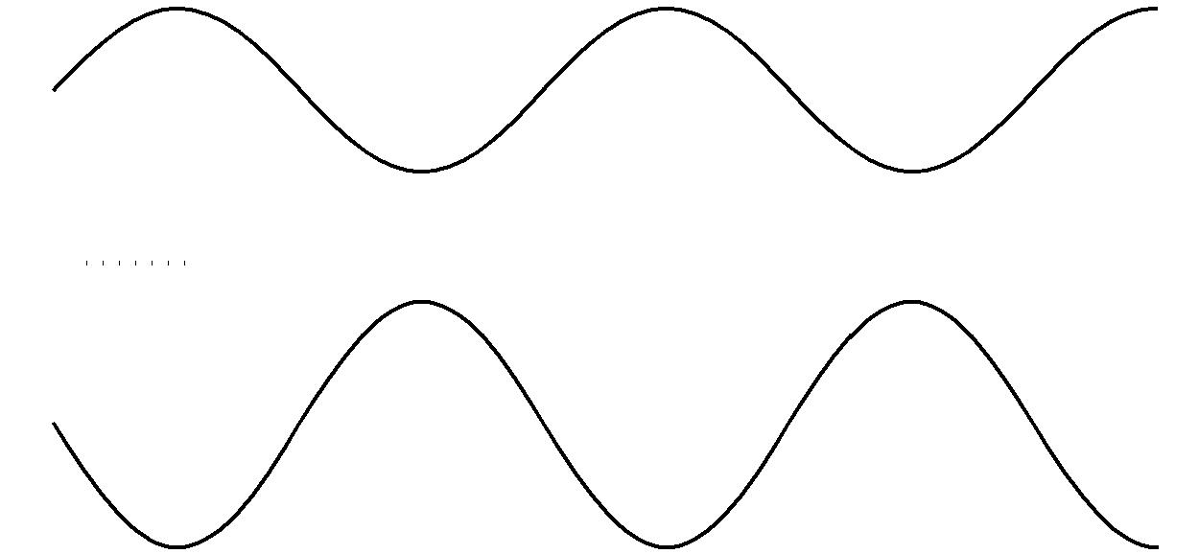

**Fig. 4.1**

1. By reference to Fig. 4.1, state one similarity and one difference between these two waves. similarity ....................................................................................................................................

difference ........................................................................................................................... **[2]**

1. Explain whether or not the two waves are coherent.

...................................................................................................................................................

...................................................................................................................................................

............................................................................................................................................ **[2]**

1. The speed of the sound waves is 340 m s–1. Determine the frequency of wave **S** and hence its wavelength.

|  |  |
| --- | --- |
| frequency = | ......................................................... Hz |
| wavelength = .................................................... | m **[4]** |

© OCR 2011

**Turn over**

**10**

1. At point **P** the two sound waves superpose (combine). By reference to Fig. 4.1 determine the resultant displacement *x* of the two waves at time
   1. *t*1= 1.5 ms

*x*1= .................................................._m**[1]**

**(ii)** *t*2= 2.25 ms.

*x*2= .................................................._m**[1]**

1. The intensity of wave **S** alone at point **P** is *I*.
   1. Show that the intensity of wave **T** alone at point **P** is 2.25 *I*.

**[2]**

1. Calculate the intensity of the resultant wave at point **P** in terms of *I*.

intensity = ...................................................... *I* **[2]**

© OCR 2011

**11**

1. The sound waves shown in Fig. 4.1 are emitted from the loudspeakers labelled **S** and **T** in Fig. 4.2 and detected by the microphone at point **P**.

**S**

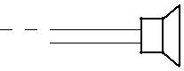

**P**



**T**

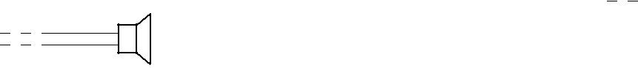

**Fig. 4.2**

1. Calculate the distance that loudspeaker **S** must be moved towards **P** to bring the two waves into phase at **P**. State your reasoning clearly.

distance = .................................................... m **[2]**

1. Describe how the intensity of the sound wave detected at **P** varies as loudspeaker **S** is moved as in **(i)**.

...........................................................................................................................................

...........................................................................................................................................

.................................................................................................................................... **[2]**

**[Total: 18]**

© OCR 2011

**Turn over**

**12**

1. **(a)** Kirchhoff’s first and second laws can be used to analyse any electrical circuit. They are aconsequence of the conservation of physical quantities in the circuit.
   1. State Kirchhoff’s **first** law and the physical quantity conserved.

...........................................................................................................................................

...........................................................................................................................................

.................................................................................................................................... **[2]**

1. State Kirchhoff’s **second** law and the physical quantity conserved.

...........................................................................................................................................

...........................................................................................................................................

...........................................................................................................................................

.................................................................................................................................... **[2]**

1. A physical quantity is also conserved in the photoelectric effect. Describe and explain the photoelectric effect.

*In your answer you should link the description to the conservation of this quantity.*

...................................................................................................................................................

...................................................................................................................................................

...................................................................................................................................................

...................................................................................................................................................

...................................................................................................................................................

...................................................................................................................................................

...................................................................................................................................................

...................................................................................................................................................

...................................................................................................................................................

...................................................................................................................................................

...................................................................................................................................................

...................................................................................................................................................

...................................................................................................................................................



............................................................................................................................................ **[6]**

**[Total: 10]**

© OCR 2011

**13**

1. **(a)** In atomic physics electron energies are often stated in*electronvolts*(eV).Define the *electronvolt*. State its value in joule.

...................................................................................................................................................

...................................................................................................................................................

............................................................................................................................................ **[2]**

1. An electron is accelerated from rest through a potential difference of 300 V.
   1. Calculate the final kinetic energy of the electron

**1** in eV

kinetic energy = ................................................... eV **[1]**

**2** in J.

kinetic energy = ...................................................... J **[1]**

**(ii)** Show that the final speed of the electron is about 1  107 m s–1.

**[2]**

**(c)** **(i)** Explain what is meant by the*de Broglie wavelength*of an electron.

...........................................................................................................................................

...........................................................................................................................................

.................................................................................................................................... **[2]**

1. Calculate the de Broglie wavelength of the electron in **(b)**.

wavelength = .................................................... m **[2]**

**[Total: 10]**

© OCR 2011

**Turn over**

**14**

1. The tungsten filament of a 12 V 24 W lamp glows white hot emitting photons across a continuous spectrum of energies. The intensity variation with wavelength of the electromagnetic radiation from the filament is shown in Fig. 7.1.

range of visible spectrum

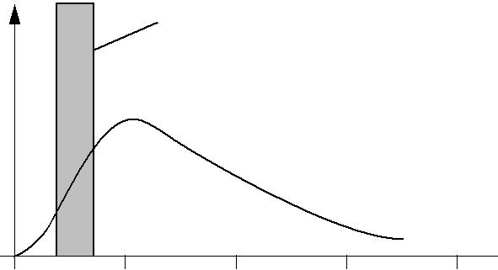

intensity

0

0 1.0 2.0 3.0 4.0

wavelength / 10–6 m

**Fig. 7.1**

1. Explain what is meant by
   1. a *photon*

...........................................................................................................................................

.................................................................................................................................... **[1]**

1. a *continuous spectrum*.

...........................................................................................................................................

.................................................................................................................................... **[1]**

1. **(i)** Fig. 7.1 shows that only a small percentage of the energy radiated from the filament lampis emitted in the visible region. The majority of the energy is emitted in other regions of the electromagnetic spectrum.
   1. State the region of the spectrum in which most of the radiation from the lamp is emitted.

............................................................................................................................. **[1]**

1. State a simple observation which is evidence for your answer to **1**.

....................................................................................................................................

............................................................................................................................. **[1]**

© OCR 2011

**15**

1. The 12 V filament lamp emits 24 W of power as electromagnetic waves. Only 5.0% of this power is converted into photons of visible light of average energy 4.0  10–19 J. Estimate the number of these visible photons emitted from the filament per second.

number = ................................................... s–1 **[3]**

1. The light from the filament is viewed through a diffraction grating, having 300 lines per millimetre. The continuous first order spectrum appears between angles *_* of 7° and 12° to the direction of the incident light. See Fig. 7.2.

spectrum

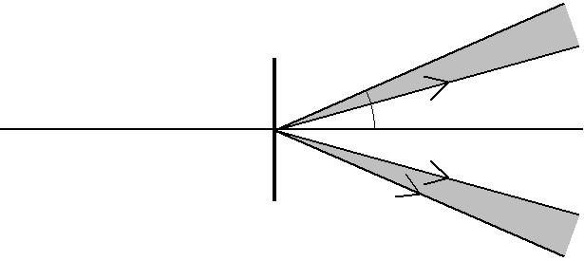

light  from  *h*

filament

grating

spectrum

**Fig. 7.2**

1. State the colour of the light that is seen at the angle of 7° ...............................................................

12° ............................................................. **[2]**

**(ii)** Calculate the angle at which green light of wavelength 5.4  10–7 m is observed in this first order spectrum.

angle = ...................................................... ° **[3]**

**[Total: 12]**

© OCR 2011

**Turn over**

**16**

**8** Fig. 8.1 shows some energy levels of the hydrogen atom. The diagram is not to scale.

|  |  |  |  |
| --- | --- | --- | --- |
|  |  | energy / 10–19 J |  |
|  |  | 0 |  |
|  |  |  |
| *n* = 5 |  | –0.87 |  |
|  |  |
|  |  |
|  |  |
| *n* = 4 |  | –1.36 |  |
|  |  |
| *n* = 3 |  | –2.42 |  |
|  |  |
| *n* = 2 |  | –5.45 |  |
|  |  |

|  |  |  |  |
| --- | --- | --- | --- |
| *n* = 1 |  | –21.8 |  |
|  |  |

**Fig. 8.1**

The energy level corresponding to the lowest energy (ground) state of the atom is *n* = 1.

The hydrogen atom is ionised when it absorbs sufficient energy for the electron to escape from the proton; that is, for the energy labelled on Fig. 8.1 to become zero or positive.

**(a) (i)** Draw an arrowed line on Fig. 8.1 to indicate the process of ionisation of an atom initiallyin its ground state. **[1]**

1. Write down the value of the minimum energy required to ionise an atom in its ground state.

minimum energy = ...................................................... J **[1]**

1. **(i)** Show that the energy change between levels required for the emission of a photon ofwavelength 490 nm is about 4  10–19 J.

**[2]**

© OCR 2011

**17**

1. Draw an arrowed line on Fig. 8.1 to indicate the transition which results in the emission of

a photon of wavelength 490 nm. **[1]**

**(c)** In space, a beam of photons of different energies passes through a cloud of atomic hydrogen gas. Explain, with a reason, what is likely to happen to photons of energy 19.38  10–19 J and to some of the hydrogen atoms.

...................................................................................................................................................

...................................................................................................................................................

...................................................................................................................................................

...................................................................................................................................................

...................................................................................................................................................

...................................................................................................................................................

...................................................................................................................................................

............................................................................................................................................ **[3]**

**[Total: 8]**

**END OF QUESTION PAPER**

© OCR 2011

**18**

**ADDITIONAL PAGE**

**If additional space is required, you should use the lined pages below. The question number(s) must be clearly shown.**

..................................................................................................................................................................

..................................................................................................................................................................

..................................................................................................................................................................

..................................................................................................................................................................

..................................................................................................................................................................

..................................................................................................................................................................

..................................................................................................................................................................

..................................................................................................................................................................

..................................................................................................................................................................

..................................................................................................................................................................

..................................................................................................................................................................

..................................................................................................................................................................

..................................................................................................................................................................

..................................................................................................................................................................

..................................................................................................................................................................

..................................................................................................................................................................

..................................................................................................................................................................

..................................................................................................................................................................

..................................................................................................................................................................

..................................................................................................................................................................

..................................................................................................................................................................

..................................................................................................................................................................

..................................................................................................................................................................

..................................................................................................................................................................

..................................................................................................................................................................

© OCR 2011

**19**

**ADDITIONAL PAGE**

..................................................................................................................................................................

..................................................................................................................................................................

..................................................................................................................................................................

..................................................................................................................................................................

..................................................................................................................................................................

..................................................................................................................................................................

..................................................................................................................................................................

..................................................................................................................................................................

..................................................................................................................................................................

..................................................................................................................................................................

..................................................................................................................................................................

..................................................................................................................................................................

..................................................................................................................................................................

..................................................................................................................................................................

..................................................................................................................................................................

..................................................................................................................................................................

..................................................................................................................................................................

..................................................................................................................................................................

..................................................................................................................................................................

..................................................................................................................................................................

..................................................................................................................................................................

..................................................................................................................................................................

..................................................................................................................................................................

..................................................................................................................................................................

..................................................................................................................................................................

..................................................................................................................................................................

..................................................................................................................................................................

© OCR 2011

**20**

**ADDITIONAL PAGE**

..................................................................................................................................................................

..................................................................................................................................................................

..................................................................................................................................................................

..................................................................................................................................................................

..................................................................................................................................................................

..................................................................................................................................................................

..................................................................................................................................................................

..................................................................................................................................................................

..................................................................................................................................................................

..................................................................................................................................................................

..................................................................................................................................................................

..................................................................................................................................................................

..................................................................................................................................................................

..................................................................................................................................................................

..................................................................................................................................................................

..................................................................................................................................................................

..................................................................................................................................................................

..................................................................................................................................................................

..................................................................................................................................................................

..................................................................................................................................................................



**Copyright Information**

OCR is committed to seeking permission to reproduce all third-party content that it uses in its assessment materials. OCR has attempted to identify and contact all copyright holders whose work is used in this paper. To avoid the issue of disclosure of answer-related information to candidates, all copyright acknowledgements are reproduced in the OCR Copyright Acknowledgements Booklet. This is produced for each series of examinations, is given to all schools that receive assessment material and is freely available to download from our public website (www.ocr.org.uk) after the live examination series.

If OCR has unwittingly failed to correctly acknowledge or clear any third-party content in this assessment material, OCR will be happy to correct its mistake at the earliest possible opportunity.

For queries or further information please contact the Copyright Team, First Floor, 9 Hills Road, Cambridge CB2 1GE.

OCR is part of the Cambridge Assessment Group; Cambridge Assessment is the brand name of University of Cambridge Local Examinations Syndicate (UCLES), which is itself a department of the University of Cambridge.

© OCR 2011