

**Friday 20 January 2012 – Morning**

**AS GCE PHYSICS A**

**G482** Electrons, Waves and Photons

|  |
| --- |
| * G 4 1 1 5 8 0 1 1 2 * |



Candidates answer on the Question Paper.

**OCR supplied materials:**

* Data, Formulae and Relationships Booklet (sent with general stationery)

**Other materials required:**

* Electronic calculator



**Duration:** 1 hour 45 minutes

* G 4 8 2 *

**INSTRUCTIONS TO CANDIDATES**

* Write your name, centre number and candidate number in the boxes above. Please write clearly and in capital letters.
* Use black ink. HB pencil may be used for graphs and diagrams only.
* Answer **all** the questions.
* Read each question carefully. Make sure you know what you have to do before starting your answer.
* Write your answer to each question in the space provided. Additional paper may be used if necessary but you must clearly show your candidate number, centre number and question number(s).
* Do **not** write in the bar codes.

**INFORMATION FOR CANDIDATES**

* The number of marks is given in brackets **[ ]** at the end of each question or part question.
* The total number of marks for this paper is **100**.
* You may use an electronic calculator.
* You are advised to show all the steps in any calculations.



• Where you see this icon you will be awarded marks for the quality of written

communication in your answer.

This means for example you should:

* + ensure that text is legible and that spelling, punctuation and grammar are accurate so that meaning is clear;
  + organise information clearly and coherently, using specialist vocabulary when appropriate.
* This document consists of **20** pages. Any blank pages are indicated.

© OCR 2012 [L/500/8055] OCR is an exempt Charity

DC (NF/SW) 36834/8 **Turn over**

**2**

Answer **all** the questions.

1. This question is about the rigid copper bars which carry the very large currents generated in a power station to the transformers. Fig. 1.1 shows such a copper bar.

bar

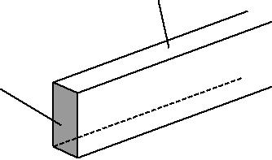

cross-sectional area *A*

**Fig. 1.1**

1. Write down a suitable word equation to define the *resistivity* of a material.

...................................................................................................................................................

...................................................................................................................................................

............................................................................................................................................. **[1]**

1. **(i)** The cross-sectional area*A*of the bar is 6.4 × 10–3m2. Calculate the resistance of a 1.0 mlength of the bar. The resistivity of copper is 1.7 × 10–8 Ω m.

resistance = ...................................................... Ω **[2]**

**(ii)** The bar carries a constant current of 8000 A. Calculate the power dissipated as heat along a 1.0 m length of it.

power = ..................................................... W **[3]**

© OCR 2012

**3**

1. The bar is 9.0 m long. Estimate the total energy in kW h lost from the bar in one day.

energy = ................................................ kW h **[2]**

1. Calculate the cost per day of operating the copper bar. The cost of 1kW h is 15p.

cost = ...................................................... p **[1]**

**(c)** Calculate the mean drift velocity *v* of the free electrons in the copper bar. The number of free electrons per unit volume in copper is 8.4 × 1028 m–3.

*v* = ............................................... m s–1**[3]**

**[Total: 12]**

© OCR 2012

**Turn over**

**4 BLANK PAGE**

**PLEASE DO NOT WRITE ON THIS PAGE**

© OCR 2012

**5**

**2** **(a)** Fig. 2.1 shows combinations of resistors connected to a power supply of e.m.f.*E*.

|  |  |  |  |  |  |  |  |  |  |  |  |  |  |  |
| --- | --- | --- | --- | --- | --- | --- | --- | --- | --- | --- | --- | --- | --- | --- |
|  |  |  |  | *E* | |  |  |  |  |  |  | *E* | |  |
|  |  |  |  |  |  |  |
|  |  |  |  |  |  |  |  |  |  |  |  |  |  |  |
|  |  |  |  |  |  |  |  |  |  |  |  |  |  |  |
|  |  |  |  |  |  |  |  |  |  |  |  |  |  |  |
|  |  |  |  |  |  |  |  |  |  |  |  |  |  |  |
|  | 120 Ω | |  |  | 240 Ω |  |  |  | 10 Ω | | | | |  |
|  |  |  |  |  |  |  |  |  |  |  |  |
|  |  |  |  |  |  |  |  |  |  |  |  |
|  |  |  |  |  |  |  |  |  | 20 Ω | | | | |  |
|  |  |  |  |  |  |  |  |
|  |  |  |  |  |  |  |  |
|  |  |  |  |  |  |  |  |  |  |  |  |  |  |  |
|  |  |  |  |  |  |  |  |  |  |  | |  |  |  |
|  |  |  |  |  |  |  |  |  | 40 Ω | | | | |  |
|  |  |  |  |  |  |  |  |  |  |  |  |  |  |  |
|  |  | | | | |  |  |  |  |  | |  |  |  |
|  | **Fig. 2.1a** | | | | |  |  | **Fig. 2.1b** | | | | | |  |



1. For the circuit of Fig. 2.1a

**1** calculate the total resistance *R*s

|  |  |  |
| --- | --- | --- |
|  | *R*s= ...................................................... | Ω **[1]** |
| **2** | state one electrical quantity which is the same for both resistors. |  |
|  | .............................................................................................................................. | **[1]** |
| **(ii)** For the circuit of Fig. 2.1b | |  |
| **1** | calculate the total resistance *R*p |  |

*R*p= ......................................................Ω**[2]**

**2** state one electrical quantity which is the same for all the resistors.

.............................................................................................................................. **[1]**

© OCR 2012

**Turn over**

**6**

**(b)** Fig. 2.2 shows the *I* *–V* characteristics of two electrical components, a resistor, line **R** and a thermistor, line **T**.

0.6

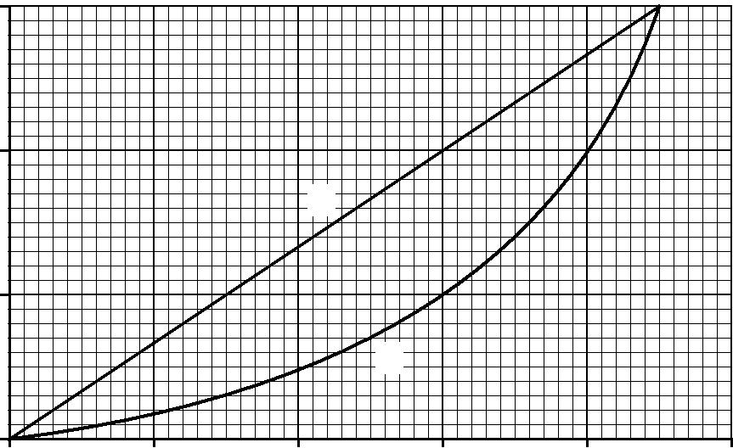

0.4

*I* / A

**R**

0.2

**T**

0

0 1.0 2.0 3.0 4.0 5.0

*V* / V

**Fig. 2.2**

1. State Ohm’s law. Use Fig. 2.2 to explain why component **R** obeys Ohm’s law.

...........................................................................................................................................

...........................................................................................................................................

...........................................................................................................................................

...........................................................................................................................................

..................................................................................................................................... **[3]**

1. The resistor and the thermistor can be connected to a variable voltage supply of negligible internal resistance in two ways as shown in Fig. 2.3a and Fig. 2.3b.

|  |  |
| --- | --- |
| *E* | *E* |
| 0.60 A |  |
|  | 0.60 A |
|  | **R** |
| **R** | **T** |
|  | **T** |
| **Fig. 2.3a** | **Fig. 2.3b** |

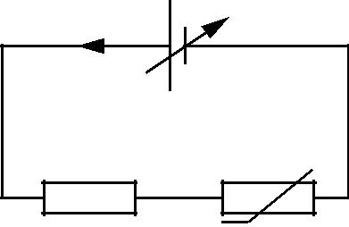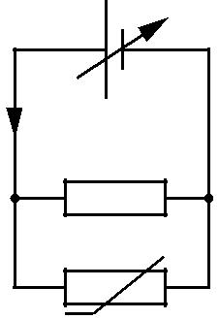

© OCR 2012

**7**

The voltage of the supply is varied in each circuit until the current drawn from it is 0.60 A. Use data from Fig. 2.2 to explain why the e.m.f. *E* of the supply is

1. 9.0 V in Fig. 2.3a

....................................................................................................................................

....................................................................................................................................

.............................................................................................................................. **[2]**

1. 3.0 V in Fig. 2.3b.

....................................................................................................................................

....................................................................................................................................

....................................................................................................................................

.............................................................................................................................. **[2]**

1. The thermistor is now connected on its own across the terminals of the supply set at 4.5 V. Fig. 2.4 shows the variation of current *I* with time *t* from the moment the thermistor is connected to the supply.

0.8

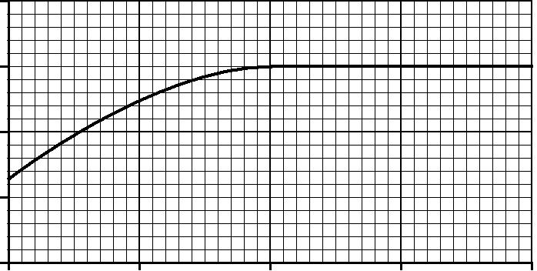

0.6

*I* / A

0.4

0.2

0

|  |  |  |  |  |
| --- | --- | --- | --- | --- |
| 0 | 1.0 | 2.0 | 3.0 | 4.0 |
|  |  |  |  | *t* / s |

**Fig. 2.4**

Explain the shape of the graph in Fig. 2.4.

...........................................................................................................................................

...........................................................................................................................................

...........................................................................................................................................

...........................................................................................................................................

...........................................................................................................................................

...........................................................................................................................................

...........................................................................................................................................

...........................................................................................................................................

..................................................................................................................................... **[3]**

**[Total: 15]**

© OCR 2012

**Turn over**

**8**

1. A cell is a source of e.m.f. When the cell is connected into a circuit the potential difference measured between its terminals, called the *terminal p.d.*, is less than its e.m.f.
   1. **(i)** Define the term*e.m.f.*

...........................................................................................................................................

...........................................................................................................................................

..................................................................................................................................... **[2]**

1. Explain why the terminal p.d. is less than the e.m.f.

...........................................................................................................................................

...........................................................................................................................................

..................................................................................................................................... **[2]**

1. In the circuit of Fig. 3.1 the cell of e.m.f. 1.6 V and internal resistance *r* is delivering a current of 0.20 A to a resistor of resistance *R.* The voltmeter reads the terminal p.d. It is 1.2 V.
   * 1. A
   1. V

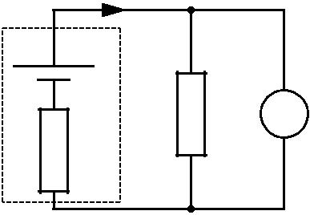

*R* V

*r*

**Fig. 3.1**

Calculate the values of

1. the resistance *R*

*R* = ......................................................Ω**[2]**

1. the internal resistance *r*.

*r* = ......................................................Ω**[2]**

© OCR 2012

**9**

**(c) (i)** The current in the resistor of Fig. 3.1 remains constant at 0.20 A for several hours.Calculate

**1** the charge which passes through the resistor in 1.5 hours

charge = .................................... unit .............. **[3]**

**2** the energy dissipated by the resistor in 1.5 hours.

energy = ...................................................... J **[2]**

1. The cell is left connected to the resistor for 12 hours. The graph of Fig. 3.2 shows the variation of current *I* with time *t*.

0.25

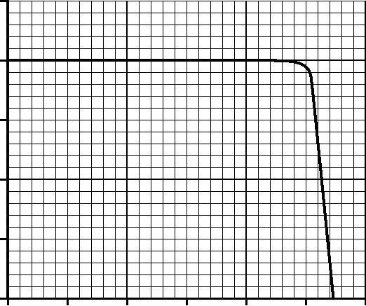

0.20

*I* / A

0.15

0.10

0.05

0

0 2 4 6 8 10 12 time / hours

**Fig. 3.2**

Describe how the current varies with time. Suggest reasons why it varies in this way.



*In your answer you should link each feature of the graph to the reason for it.*

...........................................................................................................................................

...........................................................................................................................................

...........................................................................................................................................

...........................................................................................................................................

...........................................................................................................................................

...........................................................................................................................................

..................................................................................................................................... **[4]**

**[Total: 17]**

© OCR 2012

**Turn over**

**10 BLANK PAGE**

**PLEASE DO NOT WRITE ON THIS PAGE**

© OCR 2012

**11**

1. **(a)** Explain what is meant by a*progressive wave*.

...................................................................................................................................................

...................................................................................................................................................

...................................................................................................................................................

............................................................................................................................................. **[2]**

1. Describe how a *transverse* wave differs from a *longitudinal* wave.

...................................................................................................................................................

...................................................................................................................................................

...................................................................................................................................................

*.............................................................................................................................................* **[2]**

**(c)** **(i)** Explain what is meant by*diffraction*of a wave.

...........................................................................................................................................

...........................................................................................................................................

*.....................................................................................................................................* **[1]**

1. Describe how you would demonstrate that a sound wave of wavelength 0.10 m emitted from a loudspeaker can be diffracted.

*In your answer you should make clear how your observations show that diffraction is occurring.*



...........................................................................................................................................

...........................................................................................................................................

...........................................................................................................................................

...........................................................................................................................................

...........................................................................................................................................

...........................................................................................................................................

..................................................................................................................................... **[4]**

© OCR 2012

**Turn over**

**12**

1. Fig. 4.1 shows two loudspeakers connected to a signal generator, set to a frequency of 1.2 kHz. A person walks in the direction **P** to **Q** at a distance of 3.0 m from the loudspeakers.

|  |  |  |
| --- | --- | --- |
| loudspeakers | **Q** |  |
|  |  |

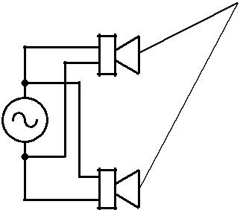

 3.0 m  **P**

**Fig. 4.1**

1. Calculate the wavelength *λ* of the sound waves emitted from the loudspeakers. speed of sound in air = 340 m s–1

*λ* = ..................................................... m **[2]**

1. Explain, either in terms of path difference or phase difference, why the intensity of the sound heard varies as the person moves along **PQ**.

...........................................................................................................................................

...........................................................................................................................................

...........................................................................................................................................

...........................................................................................................................................

...........................................................................................................................................

...........................................................................................................................................

...........................................................................................................................................

...........................................................................................................................................

...........................................................................................................................................

...........................................................................................................................................

..................................................................................................................................... **[3]**

© OCR 2012

**13**

**(iii)** The distance *x* between adjacent positions of maximum sound is 0.50 m. Calculate the separation *a* between the loudspeakers. Assume that the equation used for the interference of light also applies to sound.

*a* = ..................................................... m**[2]**

1. The connections to one of the loudspeakers are reversed. Describe the similarities and differences in what the person hears.

...........................................................................................................................................

...........................................................................................................................................

...........................................................................................................................................

...........................................................................................................................................

...........................................................................................................................................

..................................................................................................................................... **[2]**

**[Total: 18]**

© OCR 2012

**Turn over**

**14**

1. Fig. 5.1 shows a uniform string which is kept under tension between a clamp and a pulley. The frequency of the mechanical oscillator close to one end is varied so that a stationary wave is set up on the string.

|  |  |  |
| --- | --- | --- |
|  | 0.45 m |  |
| **X** | **Z** |  |
| clamp | pulley |  |
|  | **Y** |  |
| oscillator | masses |  |
|  |  |

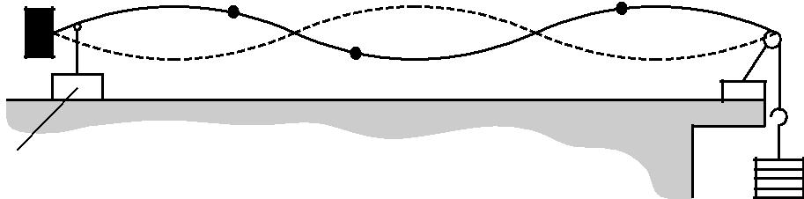

**Fig. 5.1**

1. State two features of a stationary wave.

...................................................................................................................................................

...................................................................................................................................................

...................................................................................................................................................

............................................................................................................................................. **[2]**

1. Explain how the stationary wave is formed on the string.

...................................................................................................................................................

...................................................................................................................................................

...................................................................................................................................................

...................................................................................................................................................

............................................................................................................................................. **[2]**

**(c)** The distance between the clamp and the pulley is 0.45 m. **X**, **Y** and **Z** are three points on the string. **X** and **Y** are each 0.040 m from the nearest node and **Z** is 0.090 m from the pulley. State, giving a reason for your choice, which of the points **Y** or **Z** or both oscillate

1. with the same amplitude as **X**

...........................................................................................................................................

...........................................................................................................................................

...........................................................................................................................................

..................................................................................................................................... **[2]**

© OCR 2012

**15**

1. with the same frequency as **X**

...........................................................................................................................................

...........................................................................................................................................

...........................................................................................................................................

..................................................................................................................................... **[2]**

1. in phase with **X**.

...........................................................................................................................................

...........................................................................................................................................

...........................................................................................................................................

..................................................................................................................................... **[2]**

**[Total: 10]**

© OCR 2012

**Turn over**

**16**

1. **(a)** X-rays and radio waves are two examples of electromagnetic waves.
   1. Name **two** other examples of electromagnetic waves.

...........................................................................................................................................

..................................................................................................................................... **[1]**

1. State **one** similarity and **one** difference between X-rays and radio waves.

similarity ............................................................................................................................

...........................................................................................................................................

...........................................................................................................................................

difference ...........................................................................................................................

...........................................................................................................................................

..................................................................................................................................... **[2]**

1. Explain why X-rays are easily diffracted by layers of atoms, about 2 × 10–10 m apart, but radio waves are not.

...........................................................................................................................................

...........................................................................................................................................

...........................................................................................................................................

..................................................................................................................................... **[2]**

1. On the Earth, we are all exposed to ultraviolet radiation coming from the Sun. State **one** advantage and **one** disadvantage of UV-B radiation.

...................................................................................................................................................

...................................................................................................................................................

...................................................................................................................................................

...................................................................................................................................................

............................................................................................................................................. **[2]**

**(c)** **(i)** Circle a typical value for the wavelength of an X-ray from the list below.

2 × 10–4 m 2 × 10–7 m 2 × 10–10 m 2 × 10–13 m **[1]**

© OCR 2012

**17**

1. Use your answer to **(i)** to determine how many X-ray photons must be collected to produce an energy of 1.0 × 10–6 J.

number of photons = ......................................................... **[4]**

1. A plane polarised radio wave is transmitted from a vertical aerial to a nearby receiving aerial as shown in Fig. 6.1.

transmitting aerial

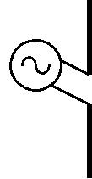

receiving aerial

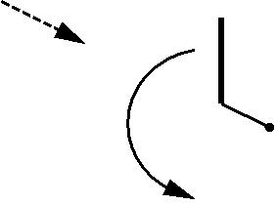

**P**



**Q**

**Fig. 6.1**

A diode, resistor and ammeter are connected in series across the terminals **P** and **Q**.

1. Draw the circuit between terminals **P** and **Q** on Fig. 6.1 in the space to the right of **PQ**.

**[2]**

1. The entire receiving aerial is rotated slowly through 180° in the direction shown by the arrow. Explain clearly what will be observed on the ammeter and how the detected signal varies.

...........................................................................................................................................

...........................................................................................................................................

...........................................................................................................................................

...........................................................................................................................................

...........................................................................................................................................

...........................................................................................................................................

..................................................................................................................................... **[3]**

**[Total: 17]**

© OCR 2012

**Turn over**

**18**

1. **(a)** State **one** experiment for each case which provides evidence that electromagnetic radiationcan behave like
   1. a stream of particles, called *photons*

..................................................................................................................................... **[1]**

1. waves.

..................................................................................................................................... **[1]**

1. A beam of ultraviolet light is incident on a clean metal surface. The graph of Fig. 7.1 shows how the maximum kinetic energy *KE*max of the electrons ejected from the surface varies with the frequency *f* of the incident light.

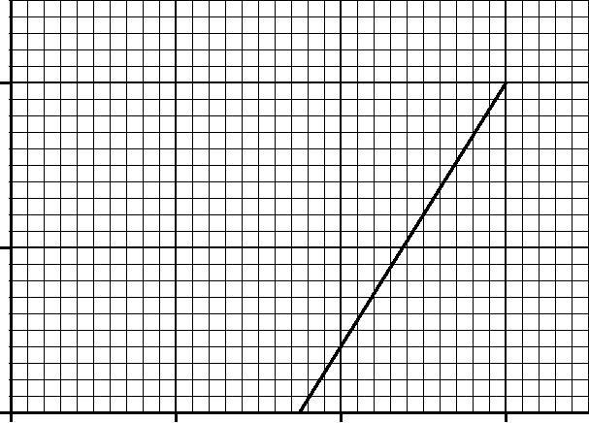

40

*KE*max/ 10–20J

20

0

0 5 10 15

*f* / 1014Hz

**Fig. 7.1**

1. Define the work function *φ* of the metal.

...........................................................................................................................................

...........................................................................................................................................

...........................................................................................................................................

..................................................................................................................................... **[1]**

© OCR 2012

**19**

1. Write down the relationship between *KE*max and *f*. Use it to explain why the *y*-intercept of the graph in Fig. 7.1 is equal to the work function of the metal and the gradient of the line is equal to the Planck constant.

...........................................................................................................................................

...........................................................................................................................................

...........................................................................................................................................

...........................................................................................................................................

...........................................................................................................................................

...........................................................................................................................................

..................................................................................................................................... **[3]**

1. Use data from Fig. 7.1 to find a value of

**1** the Planck constant

|  |  |  |
| --- | --- | --- |
|  | Planck constant = .................................................... | J s **[2]** |
| **2** | the threshold frequency of the metal |  |

threshold frequency = .................................................... Hz **[1]**

**3** the work function of the metal.

work function = ...................................................... J **[2]**

**[Total: 11]**

**END OF QUESTION PAPER**

© OCR 2012

**20**

**PLEASE DO NOT WRITE ON THIS PAGE**



**Copyright Information**

OCR is committed to seeking permission to reproduce all third-party content that it uses in its assessment materials. OCR has attempted to identify and contact all copyright holders whose work is used in this paper. To avoid the issue of disclosure of answer-related information to candidates, all copyright acknowledgements are reproduced in the OCR Copyright Acknowledgements Booklet. This is produced for each series of examinations and is freely available to download from our public website (www.ocr.org.uk) after the live examination series.

If OCR has unwittingly failed to correctly acknowledge or clear any third-party content in this assessment material, OCR will be happy to correct its mistake at the earliest possible opportunity.

For queries or further information please contact the Copyright Team, First Floor, 9 Hills Road, Cambridge CB2 1GE.

OCR is part of the Cambridge Assessment Group; Cambridge Assessment is the brand name of University of Cambridge Local Examinations Syndicate (UCLES), which is itself a department of the University of Cambridge.

© OCR 2012