|  |  |  |  |  |  |  |  |  |  |
| --- | --- | --- | --- | --- | --- | --- | --- | --- | --- |
|  |  | **THIS IS A NEW SPECIFICATION** |  |  |  |  |  |  |  |
|  | **ADVANCED SUBSIDIARY GCE** | |  |  |  |  |  |  |  |
|  | **PHYSICS A** | |  |  |  |  | **G482** | |  |
|  | Electrons, Waves and Photons | |  |  |  |  |  |  |  |
| * | Candidates answer on the Question Paper | | **Wednesday 9 June 2010** | | | | | |  |
| O |  |  |  |  |  |  | **Morning** | |  |
| C | **OCR Supplied Materials:** | |  |  |  |  |  |
|  |  |  |  |  |  |  |
| E | • Data, Formulae and Relationships Booklet | |  | **Duration:** 1 hour 45 minutes | | | | |  |
| / |  |  |  |  |
| **Other Materials Required:** | |  |  |  |  |  |  |  |
| 2 |  |  |  |  |  |  |  |
| • | Electronic calculator |  |  |  |  |  |  |  |
| 7103 |  |  |  |  |  |  |  |
|  |  | * | G | 4 | 8 | 2 | * |  |
| * |  |  |  |  |  |  |  |  |  |

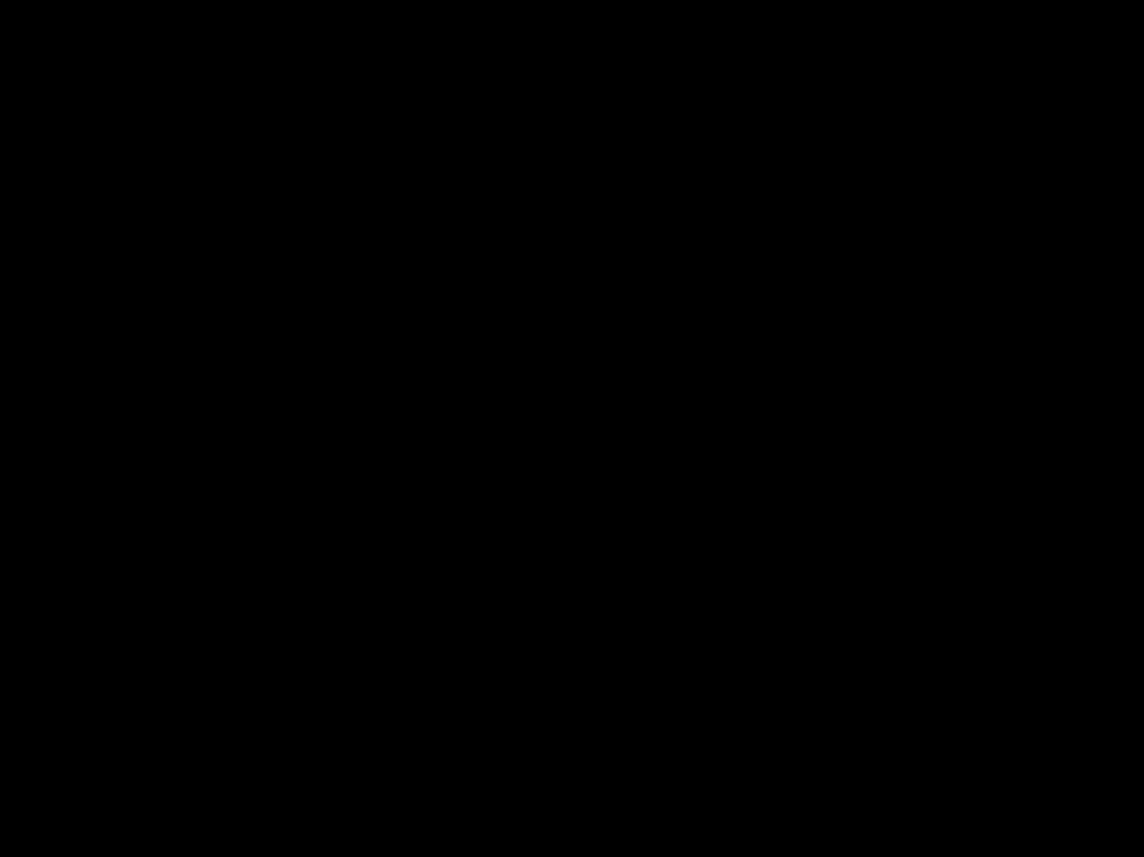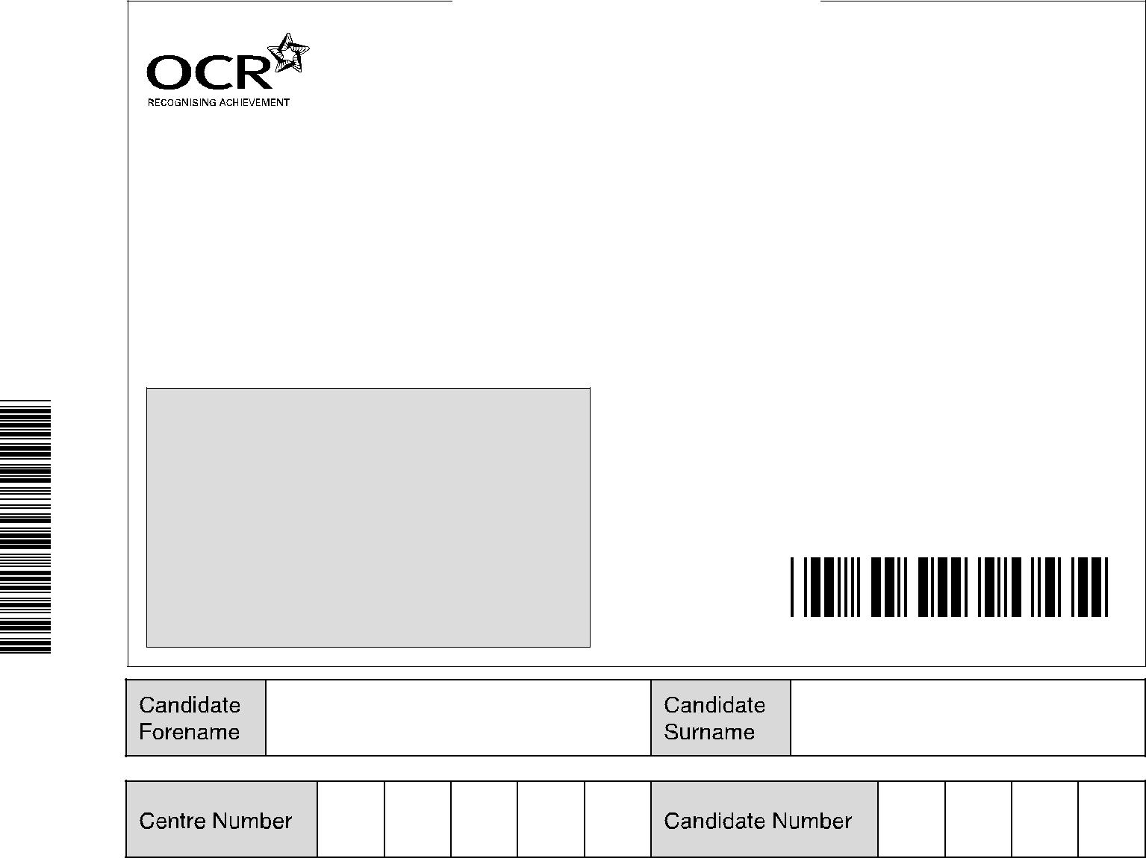

**INSTRUCTIONS TO CANDIDATES**

* Write your name clearly in capital letters, your Centre Number and Candidate Number in the boxes above.
* Use black ink. Pencil may be used for graphs and diagrams only.
* Read each question carefully and make sure that you know what you have to do before starting your answer.
* Answer **all** the questions.
* Do **not** write in the bar codes.
* Write your answer to each question in the space provided. If additional space is required, you should use the lined pages at the end of this booklet. The question number(s) must be clearly shown.

**INFORMATION FOR CANDIDATES**

* The number of marks is given in brackets **[ ]** at the end of each question or part question.
* The total number of marks for this paper is **100**.
* You may use an electronic calculator.
* You are advised to show all the steps in any calculations.

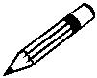

• Where you see this icon you will be awarded marks for the quality of written communication in

your answer.

This means for example you should:

* + ensure that text is legible and that spelling, punctuation and grammar are accurate so that meaning is clear;
  + organise information clearly and coherently, using specialist vocabulary when appropriate.
* This document consists of **20** pages. Any blank pages are indicated.

© OCR 2010 [L/500/8055] OCR is an exempt Charity

DCA (SHW 00376 12/08) 23017/6 **Turn over**

**2**

Answer **all** the questions.

1. **(a)** State the difference between the directions of conventional current and electron flow.

...................................................................................................................................................

............................................................................................................................................ **[1]**

**(b)** Circle one or more of the combinations of units which could act as a unit for current.

J s C s–1 V –1 J C–1

**[2]**

1. Fig. 1.1 shows a current *I* in a thick metal wire **X** connected to a longer thinner wire **Y** of the same metal as shown in Fig. 1.1.

**X**

*I* 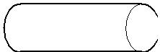 **Y** *I*



**Fig. 1.1**

1. State why the current in **Y** must also be *I*.

...........................................................................................................................................

.................................................................................................................................... **[1]**

1. Wire **Y** has half the cross-sectional area of the thicker wire **X** and is three times as long. The resistance *R*X of **X** is 12.0 .

**1** Show that the resistance *R*Y of **Y** is 72 .

**2** Calculate the total resistance *R* of both wires.

*R* = ..................................................... **[4]**

© OCR 2010

**3**

1. The mean drift velocity *v*X of electrons in **X** is 2.0 × 10–5 m s–1.

Use the fact that **X** has twice the cross-sectional area of the thinner wire **Y** to calculate the mean drift velocity *v*Y of electrons in **Y**. Show your working.

|  |  |  |  |  |
| --- | --- | --- | --- | --- |
| *v* | Y | = | ............................................... m s–1 **[2]** |  |
|  |  |  |  |
|  |  |  | **[Total: 10]** |  |

© OCR 2010

**Turn over**

**4**

1. **(a)** Two filament lamps are described as being 230 V, 25 W and 230 V, 60 W.
   1. Describe what is meant by ‘230 V, 25 W’ for a lamp.

...........................................................................................................................................

...........................................................................................................................................

...........................................................................................................................................

.................................................................................................................................... **[2]**

1. Calculate the resistance of the 25 W lamp when connected to a 230 V supply.

resistance = ..................................................... **[2]**

1. Each of the two lamps is connected across a 230 V supply. Explain which lamp has the greater current.

...........................................................................................................................................

...........................................................................................................................................

...........................................................................................................................................

.................................................................................................................................... **[2]**

1. Both lamps are connected in parallel across the 230 V supply. The resistance of the 60 W lamp in the circuit is 880 . Calculate

**1** the total resistance *R* across the supply

*R* = ...........................................................

**2** the current *I* drawn from the supply.

*I* = ..................................................... A**[4]**

© OCR 2010

**5**

1. The 60 W filament lamp is connected to a 6.0 V battery. The resistance of the lamp in this circuit is 70 . Explain why this value differs from the value given in **(a)(iv)** when the lamp is connected to the 230 V supply.

*In your answer, you should make clear how your explanation links with the observations.*

...................................................................................................................................................

...................................................................................................................................................

...................................................................................................................................................

...................................................................................................................................................

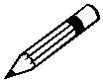

............................................................................................................................................ **[2]**

1. By mistake a householder leaves a 60 W filament lamp switched on overnight for a period of 8.0 hours.

The cost of 1.0 kilowatt-hour of electricity is 21 pence.

1. Define the *kilowatt-hour* (kWh).

...........................................................................................................................................

...........................................................................................................................................

.................................................................................................................................... **[1]**

1. Calculate the cost of this mistake to the householder.

cost = .............................................. pence **[2]**

**[Total: 15]**

© OCR 2010

**Turn over**

**6**

**3** **(a)** A student wishes to determine the power dissipated in a variable resistor connected to a cell.

1. Part of the circuit for this experiment is shown in Fig. 3.1. Complete the circuit of Fig. 3.1 showing how the variable resistor is connected and how the potential difference across it

is measured. **[3]**

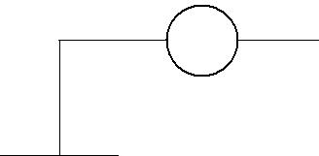

A

**Fig. 3.1**

1. Fig. 3.2 shows the variation of the potential difference *V* across the variable resistor with the current *I* in it.

|  |  |  |  |  |
| --- | --- | --- | --- | --- |
| 1.5 |  |  |  |  |
|  | **A** |  |  |  |
| 1.0 |  |  |  |  |
| *V* / V |  | **B** |  |  |
| 0.5 |  |  |  |  |
|  |  |  | **C** |  |
| 0 |  |  |  |  |
| 0 | 0.5 | 1.0 | 1.5 | 2.0 |
|  |  | *I* / A |  |  |

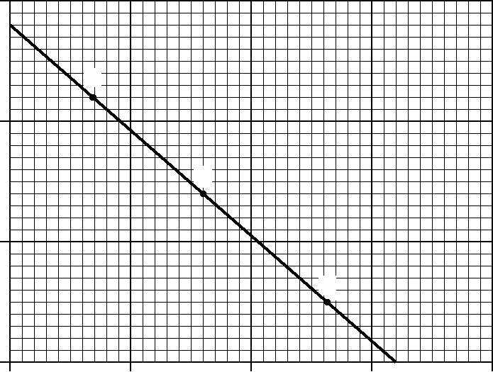

**Fig. 3.2**

1. The potential difference *V* across the variable resistor is also the terminal p.d. across the cell. Describe how the potential difference across the cell varies with the **resistance** *R*of the variable resistor. Suggest why the terminal p.d. varies in this way.

....................................................................................................................................

....................................................................................................................................

....................................................................................................................................

....................................................................................................................................

....................................................................................................................................

............................................................................................................................. **[3]**

© OCR 2010

**7**

1. By referring to the points **A** and **C**, justify that the power dissipated in the variable resistor is a maximum at or near point **B**.

....................................................................................................................................

....................................................................................................................................

....................................................................................................................................

....................................................................................................................................

............................................................................................................................. **[3]**

**3** Determine the e.m.f. *E* of the cell.

|  |  |  |
| --- | --- | --- |
|  | *E* = ..................................................... | V **[1]** |
| **4** | Calculate the internal resistance *r* of the cell. |  |

*r* = ..................................................... **[2]**

1. In Fig. 3.1, the cell is replaced by a solar cell as the source of e.m.f.

A solar cell transforms light energy into electrical energy. The maximum intensity of sunlight on the solar cell is 800 W m–2. The surface area of the cell is 2.5 × 10–3 m2.

* 1. Define the term *intensity*.

...........................................................................................................................................

.................................................................................................................................... **[1]**

1. The maximum power delivered by the solar cell to the variable resistor is 0.25 W. Determine the maximum efficiency of the solar cell.

maximum efficiency = ........................................................ **[3]**

**[Total: 16]**

© OCR 2010

**Turn over**

**8**

1. Fig. 4.1 shows how the resistance of a light-dependent resistor (LDR) varies with the intensity of the light incident on it.

5.0

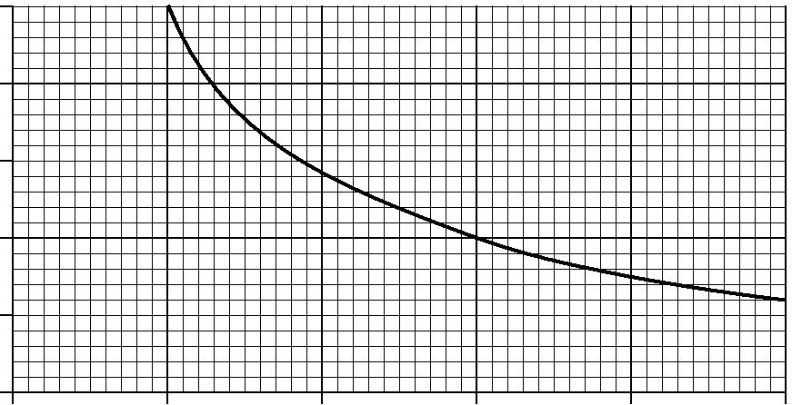LDR resistance / k

4.0

3.0

2.0

1.0

0

|  |  |  |  |  |  |
| --- | --- | --- | --- | --- | --- |
| 0 | 20 | 40 | 60 | 80 | 100 |
|  |  |  | incident light intensity / W m–2 | |  |

**Fig. 4.1**

**(a)** State how the resistance of the LDR changes with light intensity.

............................................................................................................................................ **[1]**

1. Fig. 4.2 shows a light-sensing potential divider circuit where the LDR is connected in parallel to a voltmeter and data-logger.
   * 1. k 
   1. V

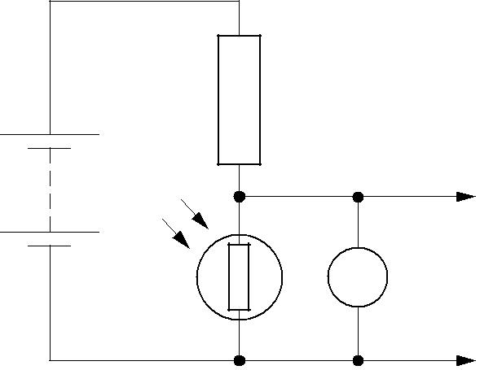

to

V data-logger

**Fig. 4.2**

The battery has an e.m.f. of 9.0 V and negligible internal resistance. The 1.2 k resistor is made of carbon. The potential difference across the LDR is 6.0 V.

1. State the potential difference across the 1.2 k resistor.

potential difference = ..................................................... V **[1]**

© OCR 2010

**9**

1. Calculate the resistance *R* of the LDR.

*R* = ................................................... k**[3]**

1. Use Fig. 4.1 to determine the light intensity when the p.d. across the LDR is 6.0 V.

light intensity = .............................................. W m–2 **[1]**

**(c) (i)** Fig. 4.1 shows that the change in resistance when the light intensity rises from 60 W m–2to 80 W m–2 is 0.5 k . State the change in resistance when the light intensity rises from

20Wm–2 to 40 W m–2.

change in resistance = ................................................... k **[1]**

1. Larger changes in data-logger voltage are observed for changes at low light intensity rather than at high light intensity. Explain this.

...........................................................................................................................................

...........................................................................................................................................

...........................................................................................................................................

.................................................................................................................................... **[2]**

1. When the circuit of Fig. 4.2 is operated for a long time, the carbon resistor becomes hot. The resistivity of carbon falls as the temperature rises. State and explain the effect on the potential difference across the LDR.

...................................................................................................................................................

...................................................................................................................................................

...................................................................................................................................................

...................................................................................................................................................

...................................................................................................................................................

............................................................................................................................................ **[3]**

© OCR 2010

**Turn over**

**10**

1. Describe briefly **two** advantages of using a data-logger to monitor the variation of light intensity falling on the LDR.

...................................................................................................................................................

...................................................................................................................................................

...................................................................................................................................................

...................................................................................................................................................

............................................................................................................................................ **[2]**

**[Total: 14]**

© OCR 2010

**11 BLANK PAGE**

**PLEASE DO NOT WRITE ON THIS PAGE**

© OCR 2010

**Turn over**

**12**

**5** **(a)** Name one common property of electromagnetic waves not shared by other waves.

............................................................................................................................................ **[1]**

1. Fig. 5.1 shows a block diagram of the seven regions of the electromagnetic spectrum, labelled **A** to **G**.

visible



|  |  |  |  |  |  |  |
| --- | --- | --- | --- | --- | --- | --- |
| **A** | **B** | **C** | **D** | **E** | **F** | **G** |
|  |  |  |  |  |  |  |



5  10–7 wavelength / m

**Fig. 5.1**

Name the principal radiation in each of the regions **A**, **C** and **F**.

|  |  |
| --- | --- |
| **A** ................................................... | **C** ................................................... |
| **F** .................................................... | **[3]** |
| **(c)** An aerial | mounted vertically transmits vertically polarised radio waves of frequency |

1.0 × 109 Hz. The waves are detected by a receiving aerial some distance away. Initially the receiving aerial is also mounted vertically as shown in Fig. 5.2.

|  |  |
| --- | --- |
| transmitting | receiving |
| aerial | aerial |
| axis | to |
|  | detector |

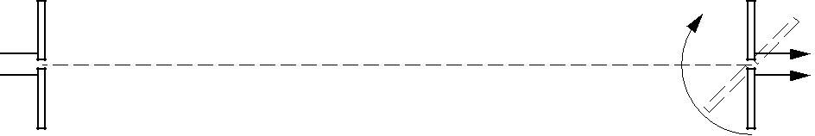

**Fig. 5.2**

The length of each aerial is half the wavelength of the radio waves.

1. Calculate the wavelength of the waves.

wavelength = .................................................... m **[2]**

1. Calculate the length of an aerial.

length = .................................................... m **[1]**

© OCR 2010

**13**

1. The receiving aerial is rotated through 180° about the axis joining the centres of the two aerials. See Fig. 5.2. Describe and explain how the output signal from the receiving aerial changes with the angle of rotation.

...........................................................................................................................................

...........................................................................................................................................

...........................................................................................................................................

...........................................................................................................................................

...........................................................................................................................................

.................................................................................................................................... **[3]**

1. Ultra-violet radiation from the Sun is often divided into three regions UV-A, UV-B and UV-C.
   1. Describe the characteristics and dangers of UV-A, UV-B and UV-C radiations.

...........................................................................................................................................

...........................................................................................................................................

...........................................................................................................................................

...........................................................................................................................................

...........................................................................................................................................

.................................................................................................................................... **[3]**

1. Explain how sunscreen protects the human skin.

...........................................................................................................................................

...........................................................................................................................................

.................................................................................................................................... **[1]**

1. Explain why electrons can be emitted from a clean metal surface illuminated with bright ultra-violet light but never when infra-red light is used, however intense.

...................................................................................................................................................

...................................................................................................................................................

...................................................................................................................................................

............................................................................................................................................ **[2]**

**[Total: 16]**

© OCR 2010

**Turn over**

**14**

1. **(a)** Describe, in terms of vibrations, the difference between a longitudinal and a transverse wave.Give one example of each wave.

...................................................................................................................................................

...................................................................................................................................................

...................................................................................................................................................

...................................................................................................................................................

...................................................................................................................................................

...................................................................................................................................................

............................................................................................................................................ **[4]**

**(b)** Fig. 6.1 shows a loudspeaker fixed near the end of a tube of length 0.6 m.

tube

loudspeaker

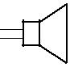

0 0.2 m 0.4 m 0.6 m

**Fig. 6.1**

The far end of the tube is closed. The frequency of the sound emitted from the loudspeaker is increased from zero. At a particular frequency a stationary wave is set up in the tube and the sound heard is much louder.

Explain how a stationary wave is formed in the tube.

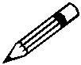

*In your answer, you should make clear how the stationary wave arises.*

...................................................................................................................................................

...................................................................................................................................................

...................................................................................................................................................

...................................................................................................................................................

...................................................................................................................................................

...................................................................................................................................................

...................................................................................................................................................

...................................................................................................................................................

............................................................................................................................................ **[3]**

© OCR 2010

**15**

1. Figs. 6.2 and 6.3 show stationary wave patterns of amplitude against position along the tube at the fundamental frequency *f*0 and the next possible harmonic at frequency 3*f*0.

|  |  |  |  |  |  |  |  |  |  |  |  |  |  |  |  |  |  |  |  |  |
| --- | --- | --- | --- | --- | --- | --- | --- | --- | --- | --- | --- | --- | --- | --- | --- | --- | --- | --- | --- | --- |
| amplitude | | | |  |  |  |  |  |  | amplitude | | | |  |  |  |  |  |  |  |
| 0 |  |  |  |  |  |  |  |  |  | 0 |  |  |  |  |  |  |  |  |  |  |
|  |  |  |  |  |  |  |  |  |  |  |  |  |  |  |  |  |  |  |
| 0.2 | | | 0.4 | | | 0.6 | | | 0.2 | | | 0.4 | | | 0.6 | | |  |
|  |  |  |
|  |  |  |  |  |  |  | distance / m | | |  |  |  |  |  |  |  | distance / m | | |  |
|  |  |  | **Fig. 6.2** | | | |  |  |  |  |  |  | **Fig. 6.3** | | | |  |  |  |  |

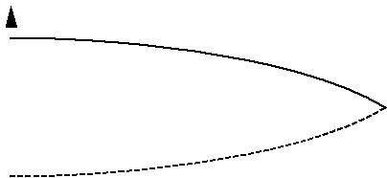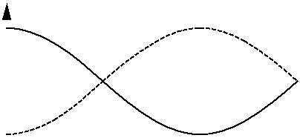

Describe the motion of the air in the tube containing the stationary wave

1. at points 0 m, 0.2 m and 0.6 m in Fig. 6.2

...........................................................................................................................................

...........................................................................................................................................

.................................................................................................................................... **[2]**

1. at points 0 m, 0.2 m and 0.4 m in Fig. 6.3.

...........................................................................................................................................

...........................................................................................................................................

.................................................................................................................................... **[2]**

**(d)** The end of the tube at 0.6 m from the loudspeaker is now opened.

1. On Fig. 6.4 sketch the stationary wave pattern of amplitude against position along the

tube at the new fundamental frequency. **[2]**

amplitude

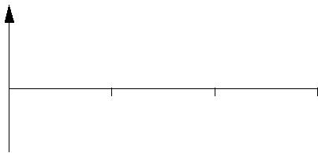

0

1. 0.4 0.6

distance / m

**Fig. 6.4**

1. State how the frequency of this stationary wave is related to the frequency *f*0 of Fig. 6.2.

.................................................................................................................................... **[1]**

**[Total: 14]**

© OCR 2010

**Turn over**

**16**

1. **(a)** When a glowing gas discharge tube is viewed through a diffraction grating an emission linespectrum is observed.
   1. Explain what is meant by a *line spectrum*.

...........................................................................................................................................

...........................................................................................................................................

.................................................................................................................................... **[2]**

1. Describe how an absorption line spectrum differs from an emission line spectrum.

...........................................................................................................................................

.................................................................................................................................... **[1]**

**(b)** A fluorescent tube used for commercial lighting contains excited mercury atoms. Two bright lines in the visible spectrum of mercury are at wavelengths 436 nm and 546 nm.

1 nm = 10–9 m

Calculate

1. the energy of a photon of violet light of wavelength 436 nm

energy = ...................................................... J **[3]**

1. the energy of a photon of green light of wavelength 546 nm.

energy = ...................................................... J **[1]**

© OCR 2010

**17**

1. Electron transitions between the three levels **A**, **B** and **C** in the energy level diagram for a mercury atom (Fig. 7.1) produce photons at 436 nm and 546 nm. The energy *E* of an electron bound to an atom is negative. The ionisation level, not shown on the diagram, defines the zero of the vertical energy scale.



*E* / 10–19J

**A**

|  |  |  |  |
| --- | --- | --- | --- |
| –7.94 |  | **B** |  |
|  |  |
| –8.86 |  | **C** |  |
|  |  |

**Fig. 7.1**

1. Draw two arrows on Fig. 7.1 to represent the transitions which give rise to these photons.

Label each arrow with its emitted photon wavelength. **[3]**

1. Use your values for the energy of the photons from **(b)** to calculate the value of the energy level **A**.

*E* = ...................................................... J**[2]**

1. The light from a distant fluorescent tube is viewed through a diffraction grating aligned so that the tube and the lines on the grating are parallel. The light from the tube is incident as a parallel beam at right angles to the diffraction grating.

The line separation on the grating is 3.3 × 10–6 m.

Calculate the angle to the straight through direction of the first order green (546 nm) image of the tube seen through the grating.

angle = ...................................................... ° **[3]**

**[Total: 15]**

**END OF QUESTION PAPER**

© OCR 2010

**18**

**ADDITIONAL PAGE**

If additional space is required, you should use the lined pages below. The question number(s) must be clearly shown.

..................................................................................................................................................................

..................................................................................................................................................................

..................................................................................................................................................................

..................................................................................................................................................................

..................................................................................................................................................................

..................................................................................................................................................................

..................................................................................................................................................................

..................................................................................................................................................................

..................................................................................................................................................................

..................................................................................................................................................................

..................................................................................................................................................................

..................................................................................................................................................................

..................................................................................................................................................................

..................................................................................................................................................................

..................................................................................................................................................................

..................................................................................................................................................................

..................................................................................................................................................................

..................................................................................................................................................................

..................................................................................................................................................................

..................................................................................................................................................................

..................................................................................................................................................................

..................................................................................................................................................................

..................................................................................................................................................................

..................................................................................................................................................................

..................................................................................................................................................................

© OCR 2010

**19**

**ADDITIONAL PAGE**

..................................................................................................................................................................

..................................................................................................................................................................

..................................................................................................................................................................

..................................................................................................................................................................

..................................................................................................................................................................

..................................................................................................................................................................

..................................................................................................................................................................

..................................................................................................................................................................

..................................................................................................................................................................

..................................................................................................................................................................

..................................................................................................................................................................

..................................................................................................................................................................

..................................................................................................................................................................

..................................................................................................................................................................

..................................................................................................................................................................

..................................................................................................................................................................

..................................................................................................................................................................

..................................................................................................................................................................

..................................................................................................................................................................

..................................................................................................................................................................

..................................................................................................................................................................

..................................................................................................................................................................

..................................................................................................................................................................

..................................................................................................................................................................

..................................................................................................................................................................

..................................................................................................................................................................

..................................................................................................................................................................

© OCR 2010

**20**

**ADDITIONAL PAGE**

..................................................................................................................................................................

..................................................................................................................................................................

..................................................................................................................................................................

..................................................................................................................................................................

..................................................................................................................................................................

..................................................................................................................................................................

..................................................................................................................................................................

..................................................................................................................................................................

..................................................................................................................................................................

..................................................................................................................................................................

..................................................................................................................................................................

..................................................................................................................................................................

..................................................................................................................................................................

..................................................................................................................................................................

..................................................................................................................................................................

..................................................................................................................................................................

..................................................................................................................................................................

..................................................................................................................................................................

..................................................................................................................................................................

..................................................................................................................................................................

..................................................................................................................................................................



**Copyright Information**

OCR is committed to seeking permission to reproduce all third-party content that it uses in its assessment materials. OCR has attempted to identify and contact all copyright holders whose work is used in this paper. To avoid the issue of disclosure of answer-related information to candidates, all copyright acknowledgements are reproduced in the OCR Copyright Acknowledgements Booklet. This is produced for each series of examinations, is given to all schools that receive assessment material and is freely available to download from our public website (www.ocr.org.uk) after the live examination series.

If OCR has unwittingly failed to correctly acknowledge or clear any third-party content in this assessment material, OCR will be happy to correct its mistake at the earliest possible opportunity.

For queries or further information please contact the Copyright Team, First Floor, 9 Hills Road, Cambridge CB2 1GE.

OCR is part of the Cambridge Assessment Group; Cambridge Assessment is the brand name of University of Cambridge Local Examinations Syndicate (UCLES), which is itself a department of the University of Cambridge.

© OCR 2010