

**Friday 25 May 2012 – Afternoon**

**AS GCE PHYSICS A**

**G482** Electrons, Waves and Photons

|  |
| --- |
| * G 4 1 1 7 2 0 6 1 2 * |



Candidates answer on the Question Paper.

**OCR supplied materials:**

* Data, Formulae and Relationships Booklet (sent with general stationery)

**Other materials required:**

* Electronic calculator



**Duration:** 1 hour 45 minutes

* G 4 8 2 *

**INSTRUCTIONS TO CANDIDATES**

* Write your name, centre number and candidate number in the boxes above. Please write clearly and in capital letters.
* Use black ink. HB pencil may be used for graphs and diagrams only.
* Answer **all** the questions.
* Read each question carefully. Make sure you know what you have to do before starting your answer.
* Write your answer to each question in the space provided. If additional space is required, you should use the lined pages at the end of this booklet. The question number(s) must be clearly shown.
* Do **not** write in the bar codes.

**INFORMATION FOR CANDIDATES**

* The number of marks is given in brackets **[ ]** at the end of each question or part question.
* The total number of marks for this paper is **100**.
* You may use an electronic calculator.

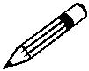

• Where you see this icon you will be awarded marks for the quality of written

communication in your answer.

This means for example your should:

* + ensure that text is legible and that spelling, punctuation and grammar are accurate so that meaning is clear;
  + organise information clearly and coherently, using specialist vocabulary when appropriate.
* This document consists of **20** pages. Any blank pages are indicated.

© OCR 2012 [L/500/8055] OCR is an exempt Charity

DC (NF/SW) 40139/5 **Turn over**

**2**

Answer **all** the questions.

1. The power of a 230 V mains filament lamp is 40 W.
   1. Define *power*.

...................................................................................................................................................

............................................................................................................................................. **[1]**

1. The lamp is connected to the 230 V supply. Calculate
   1. the current *I* in the filament

*I* = ...................................................... A**[2]**

1. the resistance *R* of the filament.

*R* = .....................................................Ω**[1]**

**(c)** The cross-sectional area of the wire of the filament is 3.0 × 10–8 m2. The resistivity of the filament when the lamp is lit is 7.0 × 10–5 Ω m. Use your answer to **(b)(ii)** to calculate the length *L* of the filament wire.

*L* = ..................................................... m**[3]**

© OCR 2012

**3**

**(d)** Explain whether the filament of a 60 W, 230 V lamp is thicker or thinner than that of the 40 W, 230 V lamp. The length and material of the filament are the same in both lamps.

...................................................................................................................................................

...................................................................................................................................................

...................................................................................................................................................

...................................................................................................................................................

...................................................................................................................................................

...................................................................................................................................................

...................................................................................................................................................

............................................................................................................................................. **[3]**

1. The 40 W filament lamp is left on for 8 hours.
   1. Calculate the charge *Q* passing through the lamp in this time.

*Q* = ...................................................... C**[2]**

1. **1** Define the*kilowatt-hour*.

...........................................................................................................................................

..................................................................................................................................... **[1]** **2** Calculate the cost of leaving the lamp switched on. The cost of 1 kWh is 22 p.

cost = ....................................................... p **[2]**

**[Total: 15]**

© OCR 2012

**Turn over**

**4**

**2** Fig. 2.1 shows the*I–V*characteristic of a light-emitting diode (LED).40

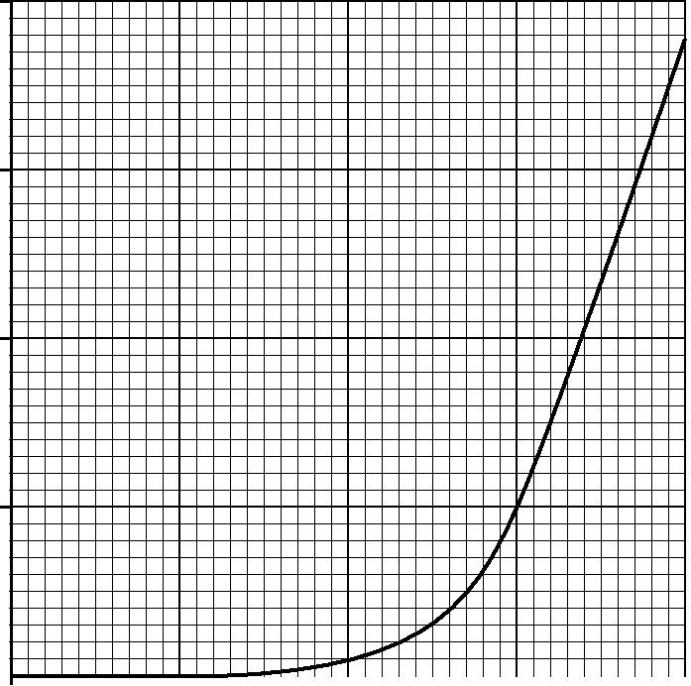

30

*I* / 10–3A

20

10

|  |  |  |  |  |  |  |  |  |  |  |  |
| --- | --- | --- | --- | --- | --- | --- | --- | --- | --- | --- | --- |
|  | 0 |  |  |  |  |  |  |  |  |  |  |
|  |  |  |  |  |  |  |  |  |  |  |
|  | 1.2 | | 1.4 | | 1.6 | | 1.8 | | 2.0 | |  |
|  |  |  |  |  |  |  |  |  | *V* / V | |  |
|  |  |  |  |  | **Fig. 2.1** | |  |  |  |  |  |
| **(a) (i)** Use Fig. 2.1 to | | |  |  |  |  |  |  |  |  |  |
| **1** | state the value of the resistance *R* below 1.4 V. | | | | | |  |  |  |  |  |
|  |  |  |  |  |  | *R* = ..................................................... |  |  |  | Ω **[1]** |  |
| **2** | determine the resistance *R* of the LED at *V* = 1.8 V. | | | | | | | |  |  |  |

*R* = .....................................................Ω**[2]**

1. At voltages *V* above 1.8 V, state whether the resistance of the LED increases, remains the same or decreases as *V* increases. Justify your answer.

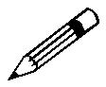

*In your answer you should link features of the graph into your justification.*

...........................................................................................................................................

...........................................................................................................................................

...........................................................................................................................................

...........................................................................................................................................

...........................................................................................................................................

...........................................................................................................................................

...........................................................................................................................................

..................................................................................................................................... **[3]**

© OCR 2012

**5**

1. A circuit is set up to obtain the *I–V* characteristic shown in Fig. 2.1. It consists of a variable 0 – 6.0 V d.c. power supply connected in **series** to a 100 Ω resistor and the LED. Fig. 2.2 shows

the variable supply. Draw the resistor, LED and suitable meters on the diagram between

terminals **X** and **Y** to complete the circuit required for the experiment. **[4]**

**X**

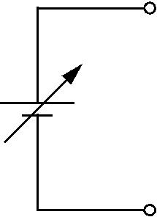

0 – 6 V d.c.

**Y**

**Fig. 2.2**

1. One or more LEDs are often used in places where, in the past, a filament lamp would have been used.

Give **one** example of such a situation.

Explain **one** advantage of using LEDs in place of a filament lamp in the situation you have chosen.

...................................................................................................................................................

...................................................................................................................................................

...................................................................................................................................................

...................................................................................................................................................

...................................................................................................................................................

............................................................................................................................................. **[2]**

**[Total: 12]**

© OCR 2012

**Turn over**

**6**

**3** Fig. 3.1 shows how the resistance of a thermistor varies with temperature.

400

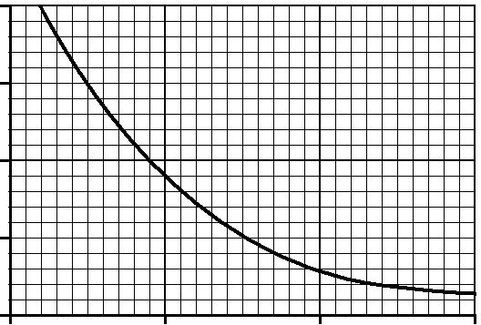

300

resistance / Ω 200

100

0

|  |  |  |  |
| --- | --- | --- | --- |
| 0 | 100 | 200 | 300 |
|  |  | temperature / °C | |

**Fig. 3.1**

The thermistor is used in the potential divider circuit of Fig. 3.2 to monitor the temperature of an oven. The 6.0 V d.c. supply has zero internal resistance and the voltmeter has infinite resistance.

*I*

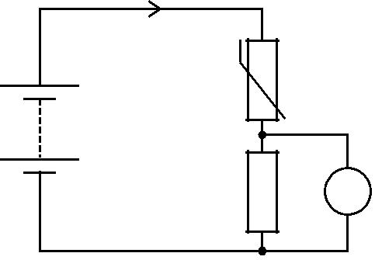

thermistor

6.0 V d.c.

200 Ω V

**Fig. 3.2**

1. State and explain how the current *I* in the circuit changes as the thermistor is heated.

...................................................................................................................................................

...................................................................................................................................................

...................................................................................................................................................

...................................................................................................................................................

...................................................................................................................................................

...................................................................................................................................................

...................................................................................................................................................

............................................................................................................................................. **[3]**

© OCR 2012

**7**

**(b)** Use Fig. 3.1 to calculate the voltmeter reading when the temperature of the oven is 240 °C.

voltmeter reading = ...................................................... V **[4]**

1. A light-dependent resistor (LDR) is another component used in sensing circuits.
   1. Complete Fig. 3.3 with an LDR between **X** and **Y**.

*I*



|  |  |  |  |  |  |  |  |  |  |  |  |
| --- | --- | --- | --- | --- | --- | --- | --- | --- | --- | --- | --- |
|  |  |  |  |  |  |  |  | **X** | | |  |
|  |  |  |  |  |  |  |  | **Y** | | |  |
|  |  |  |  |  |  |  |  |  |
| 6.0 V d.c. | | | | | | |  |  |
|  |  |
|  |  |  |  |  |
|  |  |  |  |  | 200 Ω |  |  |  | V | |  |
|  |  |  |  |  |  |  |  |  |
|  |  |  |  |  |  |  |  |  |
|  |  |  |  |  |  |  |  |  |  |  |  |
|  |  |  |  |  |  |  |  |  |  |  |  |

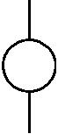

**Fig. 3.3**

**[1]**

1. State with a reason how the voltmeter reading varies as the intensity of the light incident on the LDR increases.

...........................................................................................................................................

...........................................................................................................................................

...........................................................................................................................................

...........................................................................................................................................

...........................................................................................................................................

..................................................................................................................................... **[2]**

**[Total: 10]**

© OCR 2012

**Turn over**

**8**

1. Fig. 4.1 shows part of a circuit where three resistors are connected together.
   1. Ω

 5.6 Ω 4.0 Ω 

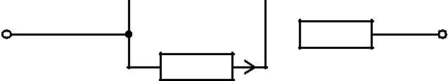

0.30 A

**Fig. 4.1**

The current in the 4.0 Ω resistor is 0.30 A.

1. Explain why the current in the 6.0 Ω resistor is 0.20 A.

...................................................................................................................................................

...................................................................................................................................................

...................................................................................................................................................

...................................................................................................................................................

............................................................................................................................................. **[2]**

**(b)** **(i)** State the law which enables you to calculate the current in the 5.6Ωresistor.

...........................................................................................................................................

..................................................................................................................................... **[1]**

1. Calculate the current in the 5.6 Ω resistor.

current = ...................................................... A **[1]**

**(c)** Calculate the total resistance *R* of the combination of resistors.

*R* = .....................................................Ω**[3]**

© OCR 2012

**9**

1. To cause the current of 0.30 A in the 4.0 Ω resistor, the resistor combination is connected to a d.c. supply of electromotive force (e.m.f.) 5.0 V.
   1. Explain the term *e*.*m*.*f*.

...........................................................................................................................................

...........................................................................................................................................

..................................................................................................................................... **[2]**

1. Show that the terminal potential difference across the supply is 4.0 V.

**[1]**

1. Calculate the internal resistance of the supply.

internal resistance = ..................................................... Ω **[2]**

**[Total: 12]**

© OCR 2012

**Turn over**

**10**

1. This question is about electrons and photons.
   1. Both electrons and photons can be considered as particles. State **two** differences between their properties.

...................................................................................................................................................

...................................................................................................................................................

............................................................................................................................................. **[2]**

1. An electron is accelerated from rest through a p.d. of 5000 V.
   1. Show that the energy gained by the electron is 8.0 × 10–16 J.

**[2]**

**(ii)** Show that the speed of the electron is about 4 × 107 m s–1.

**[3]**

**(c)** **(i)** Explain what is meant by the de Broglie wavelength of an electron.

...........................................................................................................................................

...........................................................................................................................................

..................................................................................................................................... **[1]**

1. Calculate the de Broglie wavelength of the electron in **(b)**.

wavelength = ..................................................... m **[3]**

© OCR 2012

**11**

**(d)** Calculate the wavelength of a photon of energy 8.0 × 10–16 J.

wavelength = ..................................................... m **[3]**

1. Photons of energy 9.0 × 10–19 J are incident on a clean tungsten surface causing electrons to be emitted.
   1. State the name of this process.

..................................................................................................................................... **[1]**

1. Calculate the maximum kinetic energy of the emitted electrons. Tungsten has a work function of 7.2 × 10–19 J.

maximum kinetic energy = ...................................................... J **[2]**

1. Explain why your answer to **(ii)** is a maximum value.

...........................................................................................................................................

...........................................................................................................................................

...........................................................................................................................................

...........................................................................................................................................

..................................................................................................................................... **[2]**

**[Total: 19]**

© OCR 2012

**Turn over**

**12**

1. **(a)** Define the following terms as applied to wave motion
   1. *displacement* and *amplitude*

...........................................................................................................................................

...........................................................................................................................................

...........................................................................................................................................

...........................................................................................................................................

...........................................................................................................................................

...........................................................................................................................................

..................................................................................................................................... **[2]**

1. *frequency* and *phase difference*.

...........................................................................................................................................

...........................................................................................................................................

...........................................................................................................................................

...........................................................................................................................................

...........................................................................................................................................

...........................................................................................................................................

..................................................................................................................................... **[2]**

**(b)** Fig. 6.1 shows a transverse pulse on a *slinky*, an open wound spring, at time *t* = 0. The pulse is travelling at a speed of 0.50 m s–1 from left to right. The front of the pulse is at point **X**, 0.25 m from the point **P**.

|  |  |  |  |  |
| --- | --- | --- | --- | --- |
|  |  | 0.50 m s–1 |  |  |
| 0.08 m | 0.12 m | 0.20 m |  |  |
|  |  |  |
|  |  | **X** | **P** |  |

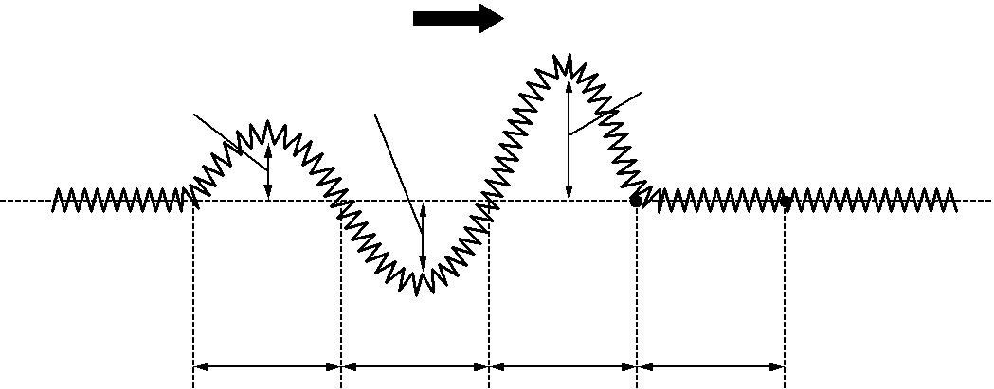

0.25 m 0.25 m 0.25 m 0.25 m

**Fig. 6.1**

© OCR 2012

**13**

On Fig. 6.2 draw a displacement *y* against time *t* graph of the motion of point **P** on the slinky from *t* = 0 to *t* = 2.5 s.

0.2

*y* / m

0

|  |  |  |  |  |  |  |  |  |  |  |  |  |  |  |  |
| --- | --- | --- | --- | --- | --- | --- | --- | --- | --- | --- | --- | --- | --- | --- | --- |
| 0 | |  | 0.5 |  | 1.0 |  | 1.5 |  | 2.0 |  |  | | 2.5 | |  |
|  |  |  |  |  |  | |  |
|  |  |  |  |  | *t* / s |  |  |
|  |  |  |  |  |  |  |  |  |  |  |  |  |  |  |
|  |  |  |  |  |  |  |  |  |  |  |  |  |  |  |
|  |  |  |  |  |  |  |  |  |  |  |  |  |  |
|  |  |  |  |  |  |  |  |  |  |  |  |  |  |  |  |

–0.2

**Fig. 6.2**

**[4]**

**[Total: 8]**

© OCR 2012

**Turn over**

**14**

**7** Fig. 7.1 shows the three lowest energy levels of the hydrogen atom, labelled *n* = 1, 2 and 3.



|  |  |  |  |
| --- | --- | --- | --- |
| –0.25 |  | *n* = 3 |  |
|  |  |
| energy / 10–18 J |  |  |  |
| –0.55 |  | *n* = 2 |  |
|  |  |

–2.2 *n* = 1

**Fig. 7.1**

1. **(i)** Explain why electron transitions between the energy levels can produce three differentwavelengths of radiation. You may draw lines on Fig. 7.1 to illustrate your explanation.

...........................................................................................................................................

...........................................................................................................................................

...........................................................................................................................................

...........................................................................................................................................

...........................................................................................................................................

...........................................................................................................................................

..................................................................................................................................... **[3]**

**(ii)** The strong red line in the hydrogen spectrum has a wavelength of 6.56 × 10–7 m.

**1** Calculate the energy of the photon at this wavelength.

energy = ...................................................... J **[2]**

1. Use Fig. 7.1 to identify the electron transition responsible for the spectral line of this wavelength.

...........................................................................................................................................

..................................................................................................................................... **[1]**

© OCR 2012

**15**

1. A parallel beam of light from a hydrogen lamp is incident on a diffraction grating. The first order red spectral line at 6.56 × 10–7 m is seen at an angle of 11.4° as shown in Fig. 7.2.

|  |  |  |
| --- | --- | --- |
|  | grating |  |
| light beam | 11.4° |  |
| from |  |
|  |  |
| hydrogen lamp |  |  |

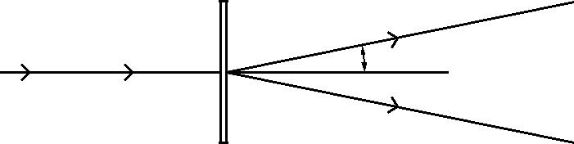

**Fig. 7.2**

1. Calculate

**1** the separation*d*of the lines on the grating

*d* = ..................................................... m**[3]**

**2** the number of lines per millimetre on the grating.

number = ....................................... lines mm–1 **[1]**

1. The hydrogen lamp also emits blue light at a wavelength of 4.86 × 10–7 m.

Draw rays on Fig. 7.2 to indicate roughly, that is without calculation, the direction of the

**first** order blue spectral line as the rays leave the grating. **[1]**

**[Total: 11]**

© OCR 2012

**Turn over**

**16**

1. **(a)** State **two** properties shared by all electromagnetic waves which distinguish them from allother waves.

...................................................................................................................................................

...................................................................................................................................................

...................................................................................................................................................

............................................................................................................................................. **[2]**

1. The two columns below list four regions of the electromagnetic spectrum and four orders of magnitude of wavelength in m.

|  |  |  |  |  |  |  |
| --- | --- | --- | --- | --- | --- | --- |
|  | **region** |  | **wavelength / m** | | |  |
|  |  |  |  |  |  |  |
|  | microwaves |  | 10–12 |  |  |  |
|  |  |  |  | |  |  |
|  | ultra violet light |  | 10–8 |  |  |  |
|  |  |  |  | |  |  |
|  | gamma rays |  | 10–6 |  | |  |
|  |  |  |  | | |  |
|  | infra red light |  | 10–4 |  | |  |
| Draw a straight line from each **region** box to the corresponding **wavelength** box. | | | | | | **[2]** |

1. Fig. 8.1 shows a microwave receiver **R** placed between a microwave transmitter **T** and a flat metal sheet.

**T** **R**

metal sheet



**Fig. 8.1**

1. Explain why **R** receives two signals of different amplitude but of the same frequency.

...........................................................................................................................................

...........................................................................................................................................

...........................................................................................................................................

...........................................................................................................................................

..................................................................................................................................... **[2]**

© OCR 2012

**17**

1. Explain why the strength of the detected signal varies between maximum and minimum values as **R** is moved towards or away from the metal sheet.

*In your answer you should make clear how the maxima and minima occur.*

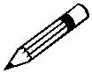

...........................................................................................................................................

...........................................................................................................................................

...........................................................................................................................................

...........................................................................................................................................

...........................................................................................................................................

...........................................................................................................................................

..................................................................................................................................... **[3]**

1. Determine the wavelength of the microwaves given that the distance between adjacent positions of maximum and minimum signal strength is 7.5 mm.

wavelength = .................................................. mm **[1]**

1. The amplitude of the signal from the transmitter is *a*. The amplitude of the two signals detected at **R** are 0.8*a* and 0.6*a*. The changes in amplitude of the detected signals are negligible as **R** moves 7.5 mm. Show that the ratio

maximum intensity of detected signal minimum intensity of detected signal

is about 50.

**[3]**

**[Total: 13]**

**END OF QUESTION PAPER**

© OCR 2012

**18**

**ADDITIONAL PAGE**

If additional space is required, you should use the lined pages below. The question number(s) must be clearly shown.

..................................................................................................................................................................

..................................................................................................................................................................

..................................................................................................................................................................

..................................................................................................................................................................

..................................................................................................................................................................

..................................................................................................................................................................

..................................................................................................................................................................

..................................................................................................................................................................

..................................................................................................................................................................

..................................................................................................................................................................

..................................................................................................................................................................

..................................................................................................................................................................

..................................................................................................................................................................

..................................................................................................................................................................

..................................................................................................................................................................

..................................................................................................................................................................

..................................................................................................................................................................

..................................................................................................................................................................

..................................................................................................................................................................

..................................................................................................................................................................

..................................................................................................................................................................

..................................................................................................................................................................

..................................................................................................................................................................

..................................................................................................................................................................

..................................................................................................................................................................

© OCR 2012

**19**

**ADDITIONAL PAGE**

..................................................................................................................................................................

..................................................................................................................................................................

..................................................................................................................................................................

..................................................................................................................................................................

..................................................................................................................................................................

..................................................................................................................................................................

..................................................................................................................................................................

..................................................................................................................................................................

..................................................................................................................................................................

..................................................................................................................................................................

..................................................................................................................................................................

..................................................................................................................................................................

..................................................................................................................................................................

..................................................................................................................................................................

..................................................................................................................................................................

..................................................................................................................................................................

..................................................................................................................................................................

..................................................................................................................................................................

..................................................................................................................................................................

..................................................................................................................................................................

..................................................................................................................................................................

..................................................................................................................................................................

..................................................................................................................................................................

..................................................................................................................................................................

..................................................................................................................................................................

..................................................................................................................................................................

..................................................................................................................................................................

© OCR 2012

**20**

**PLEASE DO NOT WRITE ON THIS PAGE**



**Copyright Information**

OCR is committed to seeking permission to reproduce all third-party content that it uses in its assessment materials. OCR has attempted to identify and contact all copyright holders whose work is used in this paper. To avoid the issue of disclosure of answer-related information to candidates, all copyright acknowledgements are reproduced in the OCR Copyright Acknowledgements Booklet. This is produced for each series of examinations and is freely available to download from our public website (www.ocr.org.uk) after the live examination series.

If OCR has unwittingly failed to correctly acknowledge or clear any third-party content in this assessment material, OCR will be happy to correct its mistake at the earliest possible opportunity.

For queries or further information please contact the Copyright Team, First Floor, 9 Hills Road, Cambridge CB2 1GE.

OCR is part of the Cambridge Assessment Group; Cambridge Assessment is the brand name of University of Cambridge Local Examinations Syndicate (UCLES), which is itself a department of the University of Cambridge.

© OCR 2012