|  |  |  |  |  |  |  |  |  |
| --- | --- | --- | --- | --- | --- | --- | --- | --- |
|  |  | **THIS IS A NEW SPECIFICATION** |  |  |  |  |  |  |
|  | **ADVANCED SUBSIDIARY GCE** | |  |  |  |  |  |  |
|  | **PHYSICS A** | |  |  |  | **G482** | |  |
|  | Electrons, Waves and Photons | |  |  |  |  |  |  |
| * | Candidates answer on the question paper | | **Thursday 21 May 2009** | | | | |  |
| O |  |  |  |  |  | **Afternoon** | |  |
| C | **OCR Supplied Materials:** | |  |  |  |  |
|  |  |  |  |  |  |
| E | • Data, Formulae & Relationships Booklet | | **Duration:** 1 hour 45 minutes | | | | |  |
| T/ |  |  |  |
| **Other Materials Required:** | |  |  |  |  |  |  |
| 6 | • | Electronic Calculator |  |  |  |  |  |  |
| 2067 |  | * | G | 4 | 8 | 2 | * |  |
| * |  |  |  |  |  |  |  |  |

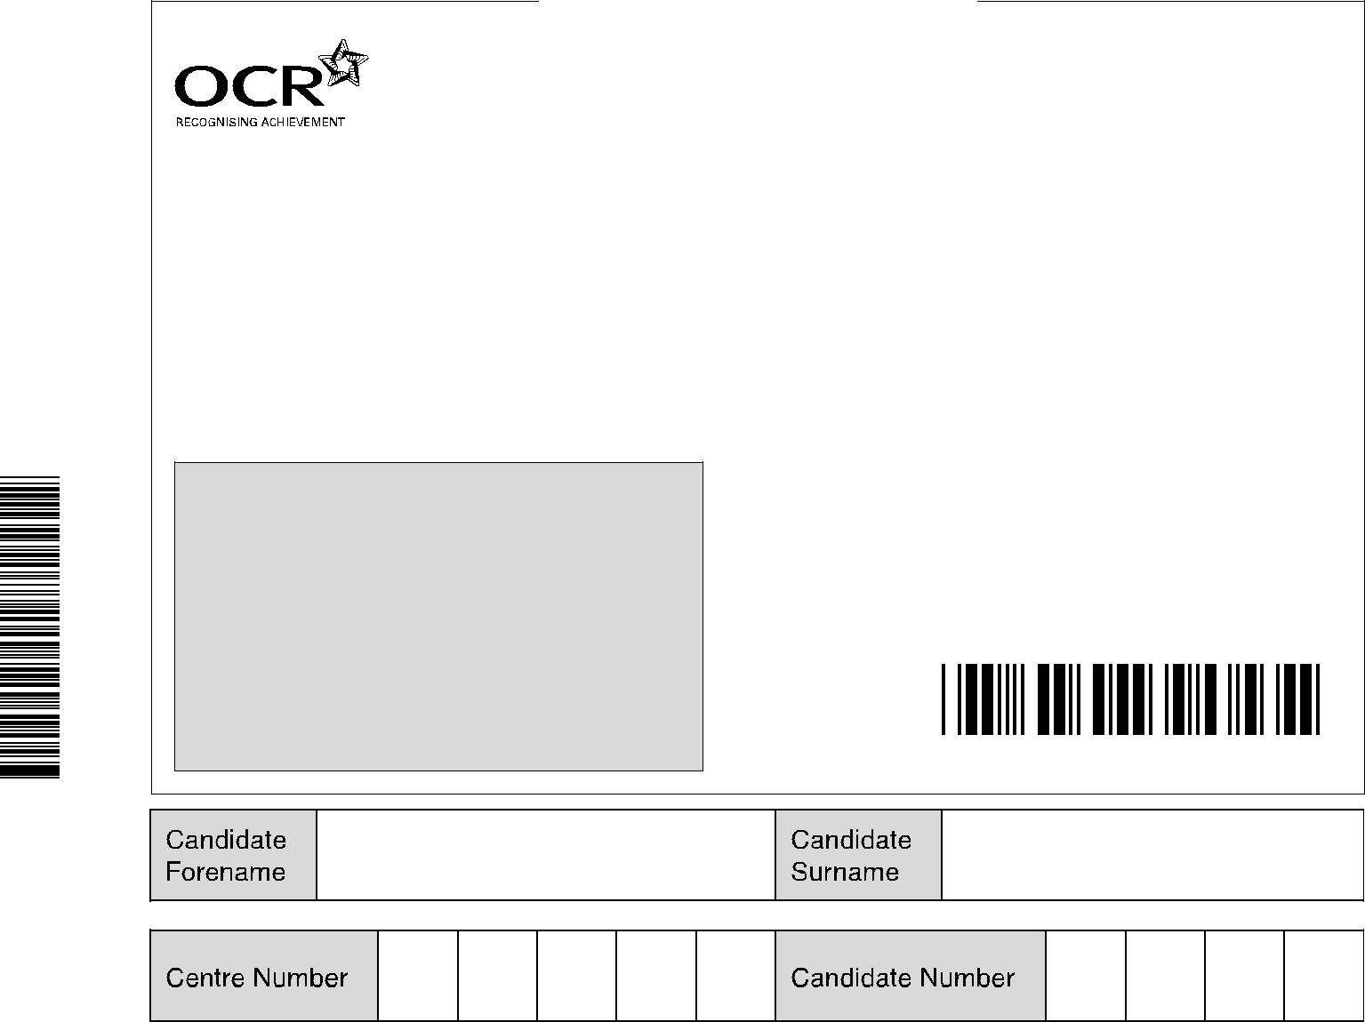

**INSTRUCTIONS TO CANDIDATES**

* Write your name clearly in capital letters, your Centre Number and Candidate Number in the boxes above.
* Use black ink. Pencil may be used for graphs and diagrams only.
* Read each question carefully and make sure that you know what you have to do before starting your answer.
* Answer **all** the questions.
* Do **not** write in the bar codes.
* Write your answer to each question in the space provided, however additional paper may be used if necessary.

**INFORMATION FOR CANDIDATES**

* The number of marks is given in brackets **[ ]** at the end of each question or part question.
* The total number of marks for this paper is **100**.
* You may use an electronic calculator.
* You are advised to show all the steps in any calculations.

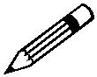

Where you see this icon you will be awarded marks for the quality of written communication in your answer.

This means for example you should:

* + ensure that text is legible and that spelling, punctuation and grammar are accurate so that meaning is clear;
  + organise information clearly and coherently, using specialist vocabulary when appropriate.
* This document consists of **20** pages. Any blank pages are indicated.

**FOR EXAMINER’S USE**

|  |  |  |
| --- | --- | --- |
| **Qu.** | **Max.** | **Mark** |
|  |  |  |
| **1** | **16** |  |
|  |  |  |
| **2** | **12** |  |
|  |  |  |
| **3** | **15** |  |
|  |  |  |
| **4** | **15** |  |
|  |  |  |
| **5** | **13** |  |
|  |  |  |
| **6** | **19** |  |
|  |  |  |
| **7** | **10** |  |
|  |  |  |
| **TOTAL** | **100** |  |
|  |  |  |

© OCR 2009 [L/500/8055] OCR is an exempt Charity

SP (SJF4891/SW) T67602/10 **Turn over**

**2**

Answer **all** the questions.

1. A set of Christmas tree lights consists of 40 identical filament lamps connected in series across a supply of 240 V.
   1. Define *resistance.*

...................................................................................................................................................

.............................................................................................................................................. **[1]**

1. Each lamp when lit normally carries a current of 250 mA. Calculate
   1. the potential difference *V* across a lamp

*V* = ..................................................... V**[1]**

1. the resistance *R* of a lamp.

*R* = .....................................................Ω**[2]**

1. Fig. 1.1 shows the results of an experiment to find how the current in one of the lamps varies with the potential difference across it.

300 current / mA

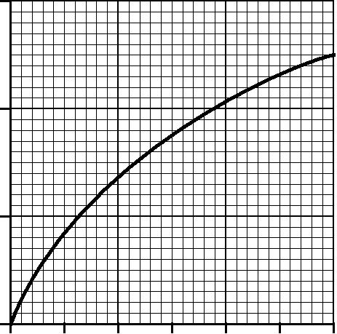

200

100

0

0 1 2 3 4 5 6 p.d./ V

**Fig. 1.1**

© OCR 2009

**3**

1. Draw a diagram of the circuit that you would use to perform this experiment.

**[3]**

1. The resistance of the lamp when at room temperature is 10 Ω. Using Fig. 1.1 sketch a graph on the axes of Fig. 1.2 of the variation of resistance *R* with current for the lamp.

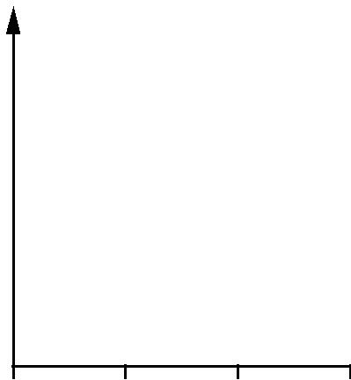

*R*

0 100 200 300 current / mA

**Fig. 1.2**

**[2]**

1. Explain why the resistance of the lamp varies as shown by the graph you have drawn on Fig. 1.2.

...........................................................................................................................................

...........................................................................................................................................

...........................................................................................................................................

...................................................................................................................................... **[2]**

© OCR 2009

**Turn over**

**4**

1. In an alternative design for the set of Christmas tree lights, a 100 Ω resistor is connected in parallel with each lamp.
   1. Describe what happens to the brightness in each set of lamps when one lamp filament burns out.

**1** *original set*......................................................................................................................

...................................................................................................................................... **[1]**

**2** *alternative set*.................................................................................................................

...........................................................................................................................................

...................................................................................................................................... **[1]**

1. Calculate the current drawn from the supply for the alternative set of lamps with all lamps working.

current = ..................................................... A **[3]**

**[Total: 16]**

© OCR 2009

**5 BLANK PAGE**

**PLEASE DO NOT WRITE ON THIS PAGE**

© OCR 2009

**Turn over**

**6**

1. **(a)** A battery of e.m.f.*E*and internal resistance*r*delivers a current*I*to a circuit of resistance*R*.Write down an equation for *E* in terms of *r*, *I* and *R*.

.............................................................................................................................................. **[1]**

1. A ‘flat’ car battery of internal resistance 0.06 Ω is to be charged using a battery charger having an e.m.f. of 14 V and internal resistance of 0.74 Ω, as shown in Fig. 2.1.

|  |  |  |  |  |  |  |  |  |  |  |  |  |
| --- | --- | --- | --- | --- | --- | --- | --- | --- | --- | --- | --- | --- |
|  |  |  |  |  |  |  |  |  |  |  | ‘flat’ |  |
|  |  |  |  |  |  |  |  |  |  |  | car |  |
|  |  |  |  |  |  |  |  |  |  |
|  |  |  |  | 0.74 Ω | + |  |  |  | 0.06 Ω battery | | |  |
| battery |  |  | + | |  |  |  |  |  |  |  |
|  |  |  |  |  |  |  |  |  |  |
|  |  |  |  |  |  |  |  |  |  |
| charger | 14 V | | | |  |  |  |  |  |  |  |  |
|  |  |  |  | 7.6 V | | |  |
|  |  |  |  |  |  |
|  |  |  |  | – |  |  |  |  |  |
|  |  |  |  |  |  |  |
|  |  |  |  |  |  |  |  |  |  |  |  |  |
|  |  |  |  |  |  |  |  |  |  |  |  |  |
|  |  |  |  |  |  |  |  |  |  |  |  |  |

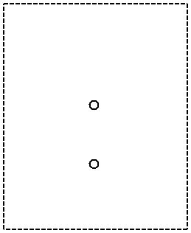

**Fig. 2.1**

You can see that the battery to be charged has its positive terminal connected to the positive terminal of the battery charger.

At the beginning of the charging process, the e.m.f. of the ‘flat’ car battery is 7.6 V.

1. For the circuit of Fig. 2.1, determine

**1** the total resistance

resistance = ..................................................... Ω **[1]**

**2** the sum of the e.m.f.s in the circuit.

e.m.f. = ..................................................... V **[1]**

1. State Kirchhoff’s second law.

...........................................................................................................................................

...................................................................................................................................... **[1]**

© OCR 2009

**7**

1. Apply the law to this circuit to calculate the initial charging current.

current = ..................................................... A **[2]**

**(c)** For the majority of the charging time of the car battery in the circuit of Fig. 2.1, the e.m.f. of the car battery is 12 V and the charging current is 2.5 A. The battery is charged at this current for 6.0 hours. Calculate, for this charging time,

1. the charge that passes through the battery

charge = ..................................................... C **[2]**

1. the energy supplied by the battery charger of e.m.f. 14 V

energy = ..................................................... J **[2]**

1. the percentage of the energy supplied by the charger which is dissipated in the internal resistances of the battery charger and the car battery.

percentage of energy = .................................................... % **[2]**

**[Total: 12]**

© OCR 2009

**Turn over**

**8**

**3** Fig. 3.1 shows a thermistor and fixed resistor of 200 Ω connected through a switch **S** to a 24 V d.c. supply of negligible internal resistance. The voltmeter across the fixed resistor has a very high resistance.

**S**

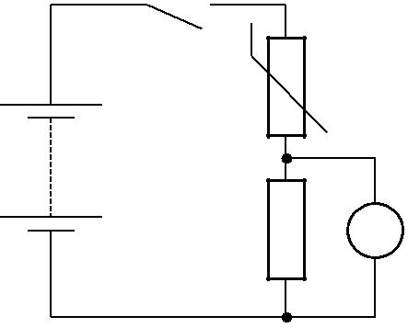

24 V

|  |  |
| --- | --- |
| 200 Ω | V |

**Fig. 3.1**

1. When the switch **S** is closed the voltmeter initially measures 8.0 V. Calculate
   1. the current *I* in the circuit

*I* = ..................................................... A**[2]**

1. the potential difference *V*T across the thermistor

*V*T= ..................................................... V**[1]**

1. the resistance *R*T of the thermistor

*R*T= .....................................................Ω**[2]**

1. the power *P*T dissipated in the thermistor.

*P*T= .................................................... W**[2]**

© OCR 2009

**9**

1. A few minutes after closing the switch **S** the voltmeter reading has risen to a steady value of 12 V. The value of the fixed resistor remains at 200 Ω.

Explain why

* 1. the potential difference across the fixed resistor has increased

...........................................................................................................................................

...........................................................................................................................................

...........................................................................................................................................

...................................................................................................................................... **[3]**

1. the resistance of the thermistor must now be 200 Ω.

...........................................................................................................................................

...................................................................................................................................... **[1]**

**(c)** Sketch, on the labelled axes of Fig. 3.2 below, a possible*I-V*characteristic for:

|  |  |  |
| --- | --- | --- |
| **(i)** | the fixed resistor. Label it **R**. | **[2]** |
| **(ii)** | the thermistor. Label it **T**. | **[2]** |



0.06

*I* / A

0.04

0.02

0

0 4.0 8.0 12.0 *V*/ V

**Fig. 3.2**

**[Total: 15]**

© OCR 2009

**Turn over**

**10**

**4** **(a) (i)** Both electromagnetic waves and sound waves can be **reflected**. State **two** other wave

|  |  |
| --- | --- |
| phenomena that apply to both electromagnetic waves and sound waves. |  |
| 1. ........................................................................................................................................ |  |
| 2. ................................................................................................................................... | **[2]** |

1. Explain why electromagnetic waves can be polarised but sound waves cannot be polarised.

...........................................................................................................................................

...................................................................................................................................... **[1]**

1. Describe briefly an experiment to demonstrate the polarisation of microwaves in the laboratory.



*In your answer you should make clear how your observations demonstrate polarisation.*

...........................................................................................................................................

...........................................................................................................................................

...........................................................................................................................................

...................................................................................................................................... **[4]**

© OCR 2009

**11**

1. A sound wave emitted by a loudspeaker consists of a single frequency. Fig. 4.1 shows the displacement against time graph of the air at a point **P** in front of the speaker.

|  |  |  |  |  |  |  |  |  |  |  |  |  |  |  |  |  |  |  |  |  |  |  |  |  |  |  |  |  |  |  |  |  |  |  |  |  |  |  |  |  |  |  |  |  |  |  |  |  |  |  |  |  |  |  |  |  |  |  |
| --- | --- | --- | --- | --- | --- | --- | --- | --- | --- | --- | --- | --- | --- | --- | --- | --- | --- | --- | --- | --- | --- | --- | --- | --- | --- | --- | --- | --- | --- | --- | --- | --- | --- | --- | --- | --- | --- | --- | --- | --- | --- | --- | --- | --- | --- | --- | --- | --- | --- | --- | --- | --- | --- | --- | --- | --- | --- | --- |
| 0.6 |  | | | | | | | | | | | | | | | | | | | | | | | | | | | | | | | | | | | | | | | | | | | | | | | | | | | | | | | | |  |
|  |  |  |  |  |  |  |  |  |  |  |  |  |  |  |  |  |  |  |  |  | |  |  |  |  |  |  |  | |  |  |  | |  |  |  |  |  |  |  |  |  |  | |  | |  |  |  |  |  |  |  |  |  | |  |
| 0.4 |  |  |  |  |  |  |  |  |  |  |  |  |  |  |  |  |  |  |  |  |  | |  |  |  |  |  |  |  | |  |  |  | |  |  |  |  |  |  |  |  |  |  | |  | |  |  |  |  |  |  |  |  |  | |  |
|  |  |  |  |  |  |  |  |  |  |  |  |  |  |  |  |  |  |  |  |  | |  |  |  |  |  |  |  | |  |  |  | |  |  |  |  |  |  |  |  |  |  | |  | |  |  |  |  |  |  |  |  |  | |  |
|  |  |  |  |  |  |  |  |  |  |  |  |  |  |  |  |  |  |  |  |  | |  |  |  |  |  |  |  | |  |  |  | |  |  |  |  |  |  |  |  |  |  | |  | |  |  |  |  |  |  |  |  |  | |  |
|  |  |  |  |  |  |  |  |  |  |  |  |  |  |  |  |  |  |  |  |  | |  |  |  |  |  |  |  | |  |  |  | |  |  |  |  |  |  |  |  |  |  | |  | |  |  |  |  |  |  |  |  |  | |  |
|  |  |  |  |  |  |  |  |  |  |  |  |  |  |  |  |  |  |  |  |  | |  |  |  |  |  |  |  | |  |  |  | |  |  |  |  |  |  |  |  |  |  | |  | |  |  |  |  |  |  |  |  |  | |  |
| displacement / mm | |  |  |  |  |  |  |  |  |  |  |  |  |  |  |  |  |  |  |  |  | |  |  |  |  |  |  |  | |  |  |  | |  |  |  |  |  |  |  |  |  |  | |  | |  |  |  |  |  |  |  |  |  | |  |
|  |  |  |  |  |  |  |  |  |  |  |  |  |  |  |  |  |  |  |  | |  |  |  |  |  |  |  | |  |  |  | |  |  |  |  |  |  |  |  |  |  | |  | |  |  |  |  |  |  |  |  |  | |  |
|  |  |  |  |  |  |  |  |  |  |  |  |  |  |  |  |  |  |  |  | |  |  |  |  |  |  |  | |  |  |  | |  |  |  |  |  |  |  |  |  |  | |  | |  |  |  |  |  |  |  |  |  | |  |
| 0.2 |  |  |  |  |  |  |  |  |  |  |  |  |  |  |  |  |  |  |  |  |  | |  |  |  |  |  |  |  | |  |  |  | |  |  |  |  |  |  |  |  |  |  | |  | |  |  |  |  |  |  |  |  |  | |  |
|  |  |  |  |  |  |  |  |  |  |  |  |  |  |  |  |  |  |  |  |  | |  |  |  |  |  |  |  | |  |  |  | |  |  |  |  |  |  |  |  |  |  | |  | |  |  |  |  |  |  |  |  |  | |  |
|  |  |  |  |  |  |  |  |  |  |  |  |  |  |  |  |  |  |  |  |  | |  |  |  |  |  |  |  | |  |  |  | |  |  |  |  |  |  |  |  |  |  | |  | |  |  |  |  |  |  |  |  |  | |  |
| 0 |  |  |  |  |  |  |  |  |  |  |  |  |  |  |  |  |  |  |  |  |  | |  |  |  |  |  |  |  | |  |  |  | |  |  |  |  |  |  |  |  |  |  | |  | |  |  |  |  |  |  |  |  |  | |  |
|  |  |  |  |  |  |  |  |  |  |  |  |  |  |  |  |  |  |  |  |  | |  |  |  |  |  |  |  | |  |  |  | |  |  |  |  |  |  |  |  |  |  | |  | |  |  |  |  |  |  |  |  |  | |  |
|  |  |  |  |  |  |  |  |  |  |  |  |  |  |  |  |  |  |  |  |  | |  |  |  |  |  |  |  | |  |  |  | |  |  |  |  |  |  |  |  |  |  | |  | |  |  |  |  |  |  |  |  |  | |  |
|  |  |  |  |  |  |  |  |  |  |  |  |  |  |  |  |  |  |  |  |  | |  |  |  |  |  |  |  | |  |  |  | |  |  |  |  |  |  |  |  |  |  | |  | |  |  |  |  |  |  |  |  |  | |  |
|  |  |  |  |  |  |  | 2.0 | | | |  |  |  |  |  |  | 4.0 | | | |  |  |  |  |  |  |  |  | 6.0 | | | |  |  |  |  |  |  |  | 8.0 | | | |  |  |  |  |  |  |  |  |  |  |  |  |  |  |
|  |  |  |  |  |  |  |  |  |  |  |  |  |  |  |  |  |  |  |  |  |  |  |  |  |  |  |  |  |  |  |  |  |  |  |  |  |  |  |  |  |  |  |
| –0.2 |  |  |  |  |  |  |  |  |  |  |  |  |  |  |  |  |  |  |  |  |  |  |  |  |  |  |  |  |  |  |  |  |  |  |  |  |  |  |  |  |  |  |  |  |  |  |  | time | | | | / ms | | | | |  |  |
|  |  |  |  |  |  |  |  |  |  |  |  |  |  |  |  |  |  |  |  |  |  |  |  |  |  |  |  |  |  |  |  |  |  |  |  |  |  |  |  |  |  |  |  |  |  |  |  |
|  |  |  |  |  |  |  |  |  |  |  |  |  |  |  |  |  |  |  |  |  | |  |  |  |  |  |  |  | |  |  |  | |  |  |  |  |  |  |  |  |  |  | |  | | | | | | | | | | | |  |
|  |  |  |  |  |  |  |  |  |  |  |  |  |  |  |  |  |  |  |  |  | |  |  |  |  |  |  |  | |  |  |  | |  |  |  |  |  |  |  |  |  |  | |  | |  |  |  |  |  |  |  |  |  | |  |
|  | |  |  |  |  |  |  |  |  |  |  |  |  |  |  |  |  |  |  |  |  | |  |  |  |  |  |  |  | |  |  |  | |  |  |  |  |  |  |  |  |  |  | |  | |  |  |  |  |  |  |  |  |  | |  |
|  | |  |  |  |  |  |  |  |  |  |  |  |  |  |  |  |  |  |  |  |  | |  |  |  |  |  |  |  | |  |  |  | |  |  |  |  |  |  |  |  |  |  | |  | |  |  |  |  |  |  |  |  |  | |  |
| –0.4 |  |  |  |  |  |  |  |  |  |  |  |  |  |  |  |  |  |  |  |  |  | |  |  |  |  |  |  |  | |  |  |  | |  |  |  |  |  |  |  |  |  |  | |  | |  |  |  |  |  |  |  |  |  | |  |
|  |  |  |  |  |  |  |  |  |  |  |  |  |  |  |  |  |  |  |  | |  |  |  |  |  |  |  | |  |  |  | |  |  |  |  |  |  |  |  |  |  | |  | |  |  |  |  |  |  |  |  |  | |  |
|  |  |  |  |  |  |  |  |  |  |  |  |  |  |  |  |  |  |  |  |  | |  |  |  |  |  |  |  | |  |  |  | |  |  |  |  |  |  |  |  |  |  | |  | |  |  |  |  |  |  |  |  |  | |  |
|  | |  |  |  |  |  |  |  |  |  |  |  |  |  |  |  |  |  |  |  |  | |  |  |  |  |  |  |  | |  |  |  | |  |  |  |  |  |  |  |  |  |  | |  | |  |  |  |  |  |  |  |  |  | |  |
|  | |  |  |  |  |  |  |  |  |  |  |  |  |  |  |  |  |  |  |  |  | |  |  |  |  |  |  |  | |  |  |  | |  |  |  |  |  |  |  |  |  |  | |  | |  |  |  |  |  |  |  |  |  | |  |
| –0.6 |  |  |  |  |  |  |  |  |  |  |  |  |  |  |  |  |  |  |  |  |  | |  |  |  |  |  |  |  | |  |  |  | |  |  |  |  |  |  |  |  |  |  | |  | |  |  |  |  |  |  |  |  |  | |  |
|  |  |  |  |  |  |  |  |  |  |  |  |  |  |  |  |  |  |  |  | |  |  |  |  |  |  |  | |  |  |  | |  |  |  |  |  |  |  |  |  |  | |  | |  |  |  |  |  |  |  |  |  | |  |
|  | | | | | | | | | | | | | | | | | | | | | | | | | | | | | | | | | | | | | | | | | | | | | | | | | | | | | | | | |  |

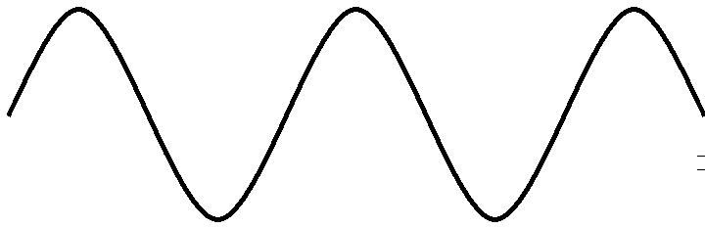

**Fig. 4.1**

1. Use Fig. 4.1 to find

**1** the amplitude of the air motion

amplitude = ................................................. mm **[1]**

**2** the frequency of the sound wave.

frequency = ................................................... Hz **[2]**

© OCR 2009

**Turn over**

**12**

1. The sound generator is adjusted so that the loudspeaker emits a sound at the original frequency and twice the **intensity**. Sketch on Fig. 4.2 the new displacement against time graph at point **P**. Explain your reasoning.

...........................................................................................................................................

...........................................................................................................................................

...........................................................................................................................................

|  |  |  |  |  |  |  |  |  |  |  |  |  |  |  |  |  |  |  |  |  |  |  |  |  |  |  |  |  |  |  |  |  |  |  |  |  |  |  |  |  |  |  |  |  |  |  |  |  |  |  |  |  |  |  |  |  |  |  |  |
| --- | --- | --- | --- | --- | --- | --- | --- | --- | --- | --- | --- | --- | --- | --- | --- | --- | --- | --- | --- | --- | --- | --- | --- | --- | --- | --- | --- | --- | --- | --- | --- | --- | --- | --- | --- | --- | --- | --- | --- | --- | --- | --- | --- | --- | --- | --- | --- | --- | --- | --- | --- | --- | --- | --- | --- | --- | --- | --- | --- |
| 0.6 |  | | | | | | | | | | | | | | | | | | | | | | | | | | | | | | | | | | | | | | | | | | | | | | | | | | | | | | | | |  |  |
|  |  |  |  |  |  |  |  |  |  |  |  |  |  |  |  |  |  |  |  |  |  |  |  |  | |  |  |  |  |  |  |  | |  |  |  | |  |  |  |  |  |  |  | | |  |  |  |  |  |  |  |  |  | |  |  |
| 0.4 |  |  |  |  |  |  |  |  |  |  |  |  |  |  |  |  |  |  |  |  |  |  |  |  |  | |  |  |  |  |  |  |  | |  |  |  | |  |  |  |  |  |  |  | | |  |  |  |  |  |  |  |  |  | |  |  |
|  |  |  |  |  |  |  |  |  |  |  |  |  |  |  |  |  |  |  |  |  |  |  |  |  | |  |  |  |  |  |  |  | |  |  |  | |  |  |  |  |  |  |  | | |  |  |  |  |  |  |  |  |  | |  |  |
|  |  |  |  |  |  |  |  |  |  |  |  |  |  |  |  |  |  |  |  |  |  |  |  |  | |  |  |  |  |  |  |  | |  |  |  | |  |  |  |  |  |  |  | | |  |  |  |  |  |  |  |  |  | |  |  |
|  |  |  |  |  |  |  |  |  |  |  |  |  |  |  |  |  |  |  |  |  |  |  |  |  | |  |  |  |  |  |  |  | |  |  |  | |  |  |  |  |  |  |  | | |  |  |  |  |  |  |  |  |  | |  |  |
|  |  |  |  |  |  |  |  |  |  |  |  |  |  |  |  |  |  |  |  |  |  |  |  |  | |  |  |  |  |  |  |  | |  |  |  | |  |  |  |  |  |  |  | | |  |  |  |  |  |  |  |  |  | |  |  |
| displacement / mm | |  |  |  |  |  |  |  |  |  |  |  |  |  |  |  |  |  |  |  |  |  |  |  |  | |  |  |  |  |  |  |  | |  |  |  | |  |  |  |  |  |  |  | | |  |  |  |  |  |  |  |  |  | |  |  |
|  |  |  |  |  |  |  |  |  |  |  |  |  |  |  |  |  |  |  |  |  |  |  |  | |  |  |  |  |  |  |  | |  |  |  | |  |  |  |  |  |  |  | | |  |  |  |  |  |  |  |  |  | |  |  |
|  |  |  |  |  |  |  |  |  |  |  |  |  |  |  |  |  |  |  |  |  |  |  |  | |  |  |  |  |  |  |  | |  |  |  | |  |  |  |  |  |  |  | | |  |  |  |  |  |  |  |  |  | |  |  |
| 0.2 |  |  |  |  |  |  |  |  |  |  |  |  |  |  |  |  |  |  |  |  |  |  |  |  |  | |  |  |  |  |  |  |  | |  |  |  | |  |  |  |  |  |  |  | | |  |  |  |  |  |  |  |  |  | |  |  |
|  |  |  |  |  |  |  |  |  |  |  |  |  |  |  |  |  |  |  |  |  |  |  |  |  | |  |  |  |  |  |  |  | |  |  |  | |  |  |  |  |  |  |  | | |  |  |  |  |  |  |  |  |  | |  |  |
|  |  |  |  |  |  |  |  |  |  |  |  |  |  |  |  |  |  |  |  |  |  |  |  |  | |  |  |  |  |  |  |  | |  |  |  | |  |  |  |  |  |  |  | | |  |  |  |  |  |  |  |  |  | |  |  |
| 0 |  |  |  |  |  |  |  |  |  |  |  |  |  |  |  |  |  |  |  |  |  |  |  |  |  | |  |  |  |  |  |  |  | |  |  |  | |  |  |  |  |  |  |  | | |  |  |  |  |  |  |  |  |  | |  |  |
|  |  |  |  |  |  |  |  |  |  |  |  |  |  |  |  |  |  |  |  |  |  |  |  |  | |  |  |  |  |  |  |  | |  |  |  | |  |  |  |  |  |  |  | | |  |  |  |  |  |  |  |  |  | |  |  |
|  |  |  |  |  |  |  |  |  |  |  |  |  |  |  |  |  |  |  |  |  |  |  |  |  | |  |  |  |  |  |  |  | |  |  |  | |  |  |  |  |  |  |  | | |  |  |  |  |  |  |  |  |  | |  |  |
|  |  |  |  |  |  |  |  |  |  |  |  |  |  |  |  |  |  |  |  |  |  |  |  |  | |  |  |  |  |  |  |  | |  |  |  | |  |  |  |  |  |  |  | | |  |  |  |  |  |  |  |  |  | |  |  |
|  |  |  |  |  |  |  |  |  |  |  | 2.0 | | | |  |  |  |  |  |  | 4.0 | | | |  |  |  |  |  |  |  |  | 6.0 | | | |  |  |  |  |  |  |  |  | 8.0 | | | | |  |  |  |  |  |  |  |  |  |
|  |  |  |  |  |  |  |  |  |  |  |  |  |  |  |  |  |  |  |  |  |  |  |  |  |  |  |  |  |  |  |  |  |  |  |  |  |  |  |  |  |  |  |
| –0.2 |  |  |  |  |  |  |  |  |  |  |  |  |  |  |  |  |  |  |  |  |  |  |  |  |  |  |  |  |  |  |  |  |  |  |  |  |  |  |  |  |  |  |  |  |  |  |  | time | | | | / ms | | | | |  |  |  |
|  |  |  |  |  |  |  |  |  |  |  |  |  |  |  |  |  |  |  |  |  |  |  |  |  |  |  |  |  |  |  |  |  |  |  |  |  |  |  |  |  |  |  |  |  |  |  |  |  |
|  |  |  |  |  |  |  |  |  |  |  |  |  |  |  |  |  |  |  |  |  |  |  |  |  | |  |  |  |  |  |  |  | |  |  |  | |  |  |  |  |  |  |  | | | | | | | | | | | | |  |  |
|  |  |  |  |  |  |  |  |  |  |  |  |  |  |  |  |  |  |  |  |  |  |  |  |  | |  |  |  |  |  |  |  | |  |  |  | |  |  |  |  |  |  |  | | |  |  |  |  |  |  |  |  |  | |  |  |
|  | |  |  |  |  |  |  |  |  |  |  |  |  |  |  |  |  |  |  |  |  |  |  |  |  | |  |  |  |  |  |  |  | |  |  |  | |  |  |  |  |  |  |  | | |  |  |  |  |  |  |  |  |  | |  |  |
|  | |  |  |  |  |  |  |  |  |  |  |  |  |  |  |  |  |  |  |  |  |  |  |  |  | |  |  |  |  |  |  |  | |  |  |  | |  |  |  |  |  |  |  | | |  |  |  |  |  |  |  |  |  | |  |  |
| –0.4 |  |  |  |  |  |  |  |  |  |  |  |  |  |  |  |  |  |  |  |  |  |  |  |  |  | |  |  |  |  |  |  |  | |  |  |  | |  |  |  |  |  |  |  | | |  |  |  |  |  |  |  |  |  | |  |  |
|  |  |  |  |  |  |  |  |  |  |  |  |  |  |  |  |  |  |  |  |  |  |  |  | |  |  |  |  |  |  |  | |  |  |  | |  |  |  |  |  |  |  | | |  |  |  |  |  |  |  |  |  | |  |  |
|  |  |  |  |  |  |  |  |  |  |  |  |  |  |  |  |  |  |  |  |  |  |  |  |  | |  |  |  |  |  |  |  | |  |  |  | |  |  |  |  |  |  |  | | |  |  |  |  |  |  |  |  |  | |  |  |
|  | |  |  |  |  |  |  |  |  |  |  |  |  |  |  |  |  |  |  |  |  |  |  |  |  | |  |  |  |  |  |  |  | |  |  |  | |  |  |  |  |  |  |  | | |  |  |  |  |  |  |  |  |  | |  |  |
|  | |  |  |  |  |  |  |  |  |  |  |  |  |  |  |  |  |  |  |  |  |  |  |  |  | |  |  |  |  |  |  |  | |  |  |  | |  |  |  |  |  |  |  | | |  |  |  |  |  |  |  |  |  | |  |  |
| –0.6 |  |  |  |  |  |  |  |  |  |  |  |  |  |  |  |  |  |  |  |  |  |  |  |  |  | |  |  |  |  |  |  |  | |  |  |  | |  |  |  |  |  |  |  | | |  |  |  |  |  |  |  |  |  | |  |  |
|  |  |  |  |  |  |  |  |  |  |  |  |  |  |  |  |  |  |  |  |  |  |  |  | |  |  |  |  |  |  |  | |  |  |  | |  |  |  |  |  |  |  | | |  |  |  |  |  |  |  |  |  | |  |  |
|  |  |  |  |  |  |  |  |  |  |  |  |  |  |  |  |  |  |  |  |  |  |  |  |  |  |  |  |  |  |  |  |  |  |  |  |  |  |  |  |  |  |  |  | **[3]** | | | | | | | | | | | | | |  |
|  |  |  |  |  |  |  |  |  |  |  |  |  |  |  |  |  |  |  |  |  |  |  |  |  |  |  |  |  |  |  |  |  |  |  |  |  |  |  |  |  |  |  |  |  |  |
|  |  |  |  |  |  |  |  |  |  | **Fig. 4.2** | | | | | | | | | | | |  |  |  |  |  |  |  |  |  |  |  |  |  |  |  |  |  |  |  |  |  |  |  |  |  |  |  |  |  |  |  |  |  |  |  |  |  |  |



1. Suggest, with reasons, the apparatus that you would choose to detect and measure the frequency of the sound wave at **P**.

...........................................................................................................................................

...........................................................................................................................................

...........................................................................................................................................

...........................................................................................................................................

...........................................................................................................................................

...........................................................................................................................................

...................................................................................................................................... **[2]**

**[Total: 15]**

© OCR 2009

**13 BLANK PAGE**

**PLEASE DO NOT WRITE ON THIS PAGE**

© OCR 2009

**Turn over**

**14**

1. **(a)** When used to describe stationary (standing) waves explain the terms
   1. node .............................................................................................................................

...................................................................................................................................... **[1]**

**(ii)** antinode. ............................................................................................................................

...................................................................................................................................... **[1]**

1. Fig. 5.1 shows a string fixed at one end under tension. The frequency of the mechanical oscillator close to the fixed end is varied until a stationary wave is formed on the string.

90 cm

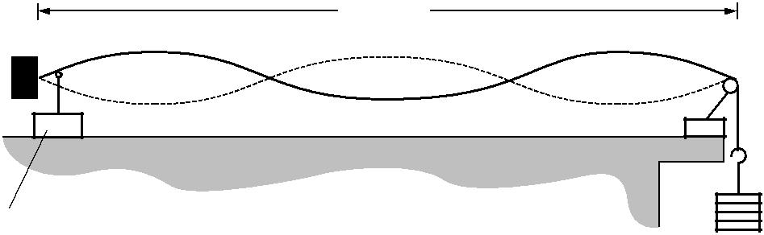

|  |  |
| --- | --- |
| clamp | pulley |

|  |  |  |
| --- | --- | --- |
| oscillator | masses |  |
|  |  |

**Fig. 5.1**

1. Explain with reference to a progressive wave on the string how the stationary wave is formed.

|  |  |  |
| --- | --- | --- |
|  | ........................................................................................................................................... | |
|  | ........................................................................................................................................... | |
|  | ........................................................................................................................................... | |
|  | ........................................................................................................................................... | |
|  | ........................................................................................................................................... | |
|  | ........................................................................................................................................... | |
|  | ...................................................................................................................................... | **[3]** |
| **(ii)** | On Fig. 5.1 label one node with the letter **N** and one antinode with the letter **A**. | **[1]** |

1. State the number of antinodes on the string in Fig. 5.1.

number of antinodes = ......................................................... **[1]**

© OCR 2009

**15**

1. The frequency of the oscillator causing the stationary wave shown in Fig. 5.1 is 120 Hz. The length of the string between the fixed end and the pulley is 90 cm.

Calculate the speed of the progressive wave on the string.

speed = ............................................... m s–1 **[3]**

**(c)** The speed*v*of a progressive wave on a stretched string is given by the formula



*v* = *k W*

where *k* is a constant for that string. *W* is the tension in the string which is equal to the weight of the mass hanging from the end of the string.

In **(b)** the weight of the mass on the end of the string is 4.0 N. The oscillator continues to vibrate the string at 120 Hz. Explain whether or not you would expect to observe a stationary wave on the string when the weight of the suspended mass is changed to 9.0 N.

...................................................................................................................................................

...................................................................................................................................................

...................................................................................................................................................

...................................................................................................................................................

...................................................................................................................................................

.............................................................................................................................................. **[3]**

**[Total: 13]**

© OCR 2009

**Turn over**

**16**

1. **(a)** A parallel beam of red light of wavelength 6.3 × 10–7m from a laser is incident normally on adiffraction grating as shown in Fig. 6.1.

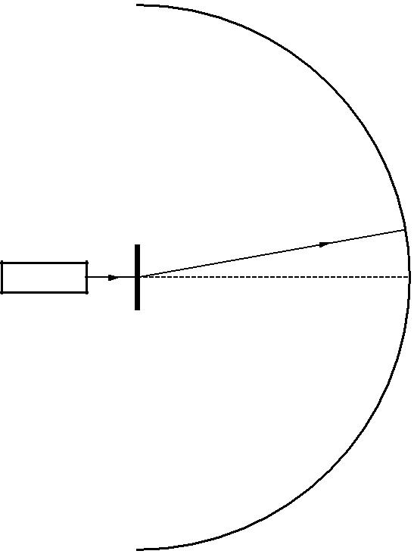

diffraction grating

laser



screen

first order  spot

 zeroth order spot

**Fig. 6.1**

Bright red spots are observed on the curved screen placed beyond the grating.

1. The diffraction grating has 300 lines per millimetre. Show that the separation *d* between adjacent lines of the grating is 3.3 × 10–6 m.

**[1]**

1. Calculate the angle *θ* at which the first order red spot is seen. This is the first spot away from the straight through position.

*θ* = .......................................... degrees **[3]**

1. The screen curves around the full 180° in front of the grating. Explain why there are eleven bright red spots on the screen.

...........................................................................................................................................

...........................................................................................................................................

...........................................................................................................................................

...........................................................................................................................................

...................................................................................................................................... **[3]**

© OCR 2009

**17**

1. Calculate
   1. the energy of each photon of light emitted by the laser at a wavelength of 6.3 × 10–7 m

energy = ..................................................... J **[2]**

1. the number of photons emitted each second to produce a power of 0.50 mW.

number = ........................................................ **[2]**

1. **(i)** A beam of electrons in a vacuum can travel through a thin sheet of graphiteperpendicular to the beam to produce a diffraction pattern of rings on a fluorescent screen beyond the graphite sheet. Explain why this pattern is produced.

...........................................................................................................................................

...........................................................................................................................................

...........................................................................................................................................

...........................................................................................................................................

...................................................................................................................................... **[3]**

1. Calculate

**1** the speed *v* of electrons with a de Broglie wavelength of 5.0 × 10–11 m

|  |  |  |
| --- | --- | --- |
|  | *v* = ............................................... | m s–1 **[2]** |
| **2** | the potential difference *V* required to accelerate the electrons to this speed. | |

*V* = ..................................................... V**[3]**

**[Total: 19]**

© OCR 2009

**Turn over**

**18**

1. In 1905 Einstein presented a theory to explain the photoelectric effect using the concept of quantisation of radiation proposed by Planck in 1900.
   1. Show, with the aid of a suitably labelled diagram, the arrangement of apparatus that could be used to demonstrate the photoelectric effect. Describe how you would use the apparatus and what would be observed.



*In your answer you should make clear how your observations provide evidence for the photoelectric effect.*

...................................................................................................................................................

...................................................................................................................................................

...................................................................................................................................................

...................................................................................................................................................

...................................................................................................................................................

...................................................................................................................................................

...................................................................................................................................................

...................................................................................................................................................

...................................................................................................................................................

...................................................................................................................................................

...................................................................................................................................................

.............................................................................................................................................. **[5]**

© OCR 2009

**19**

1. Describe how the photoelectric effect can be explained in terms of the physics of quantum behaviour.

...................................................................................................................................................

...................................................................................................................................................

...................................................................................................................................................

...................................................................................................................................................

...................................................................................................................................................

...................................................................................................................................................

...................................................................................................................................................

...................................................................................................................................................

...................................................................................................................................................

...................................................................................................................................................

...................................................................................................................................................

...................................................................................................................................................

...................................................................................................................................................

.............................................................................................................................................. **[5]**

**[Total: 10]**

**END OF QUESTION PAPER**

© OCR 2009

**20**

**PLEASE DO NOT WRITE ON THIS PAGE**



**Copyright Information**

OCR is committed to seeking permission to reproduce all third-party content that it uses in its assessment materials. OCR has attempted to identify and contact all copyright holders whose work is used in this paper. To avoid the issue of disclosure of answer-related information to candidates, all copyright acknowledgements are reproduced in the OCR Copyright Acknowledgements Booklet. This is produced for each series of examinations, is given to all schools that receive assessment material and is freely available to download from our public website (www.ocr.org.uk) after the live examination series.

If OCR has unwittingly failed to correctly acknowledge or clear any third-party content in this assessment material, OCR will be happy to correct its mistake at the earliest possible opportunity.

For queries or further information please contact the Copyright Team, First Floor, 9 Hills Road, Cambridge CB2 1PB.

OCR is part of the Cambridge Assessment Group; Cambridge Assessment is the brand name of University of Cambridge Local Examinations Syndicate (UCLES), which is itself a department of the University of Cambridge.

© OCR 2009