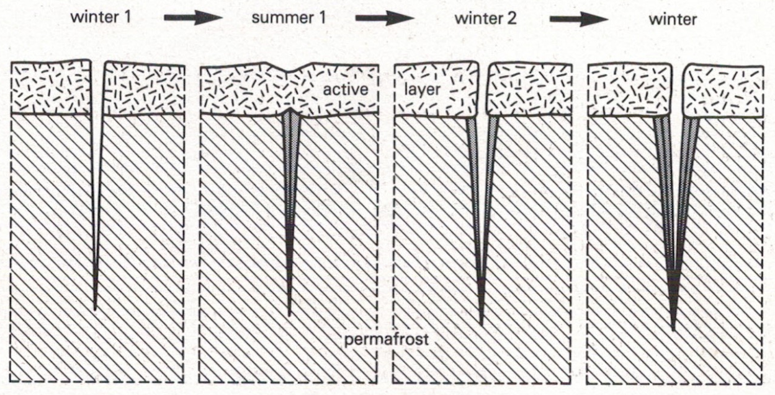
Ice wedges
Ice wedge polygons - formation

