1
2
3
4
5
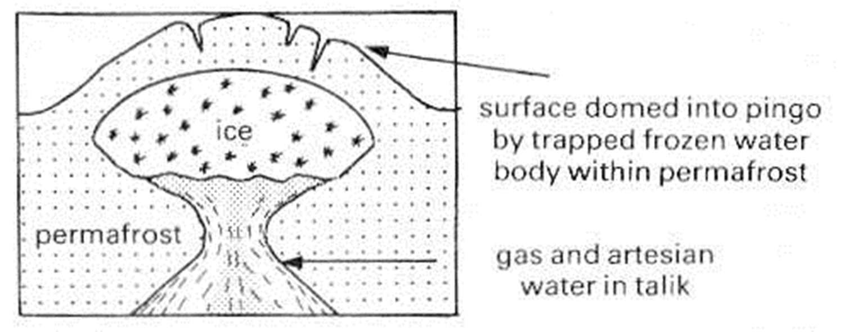
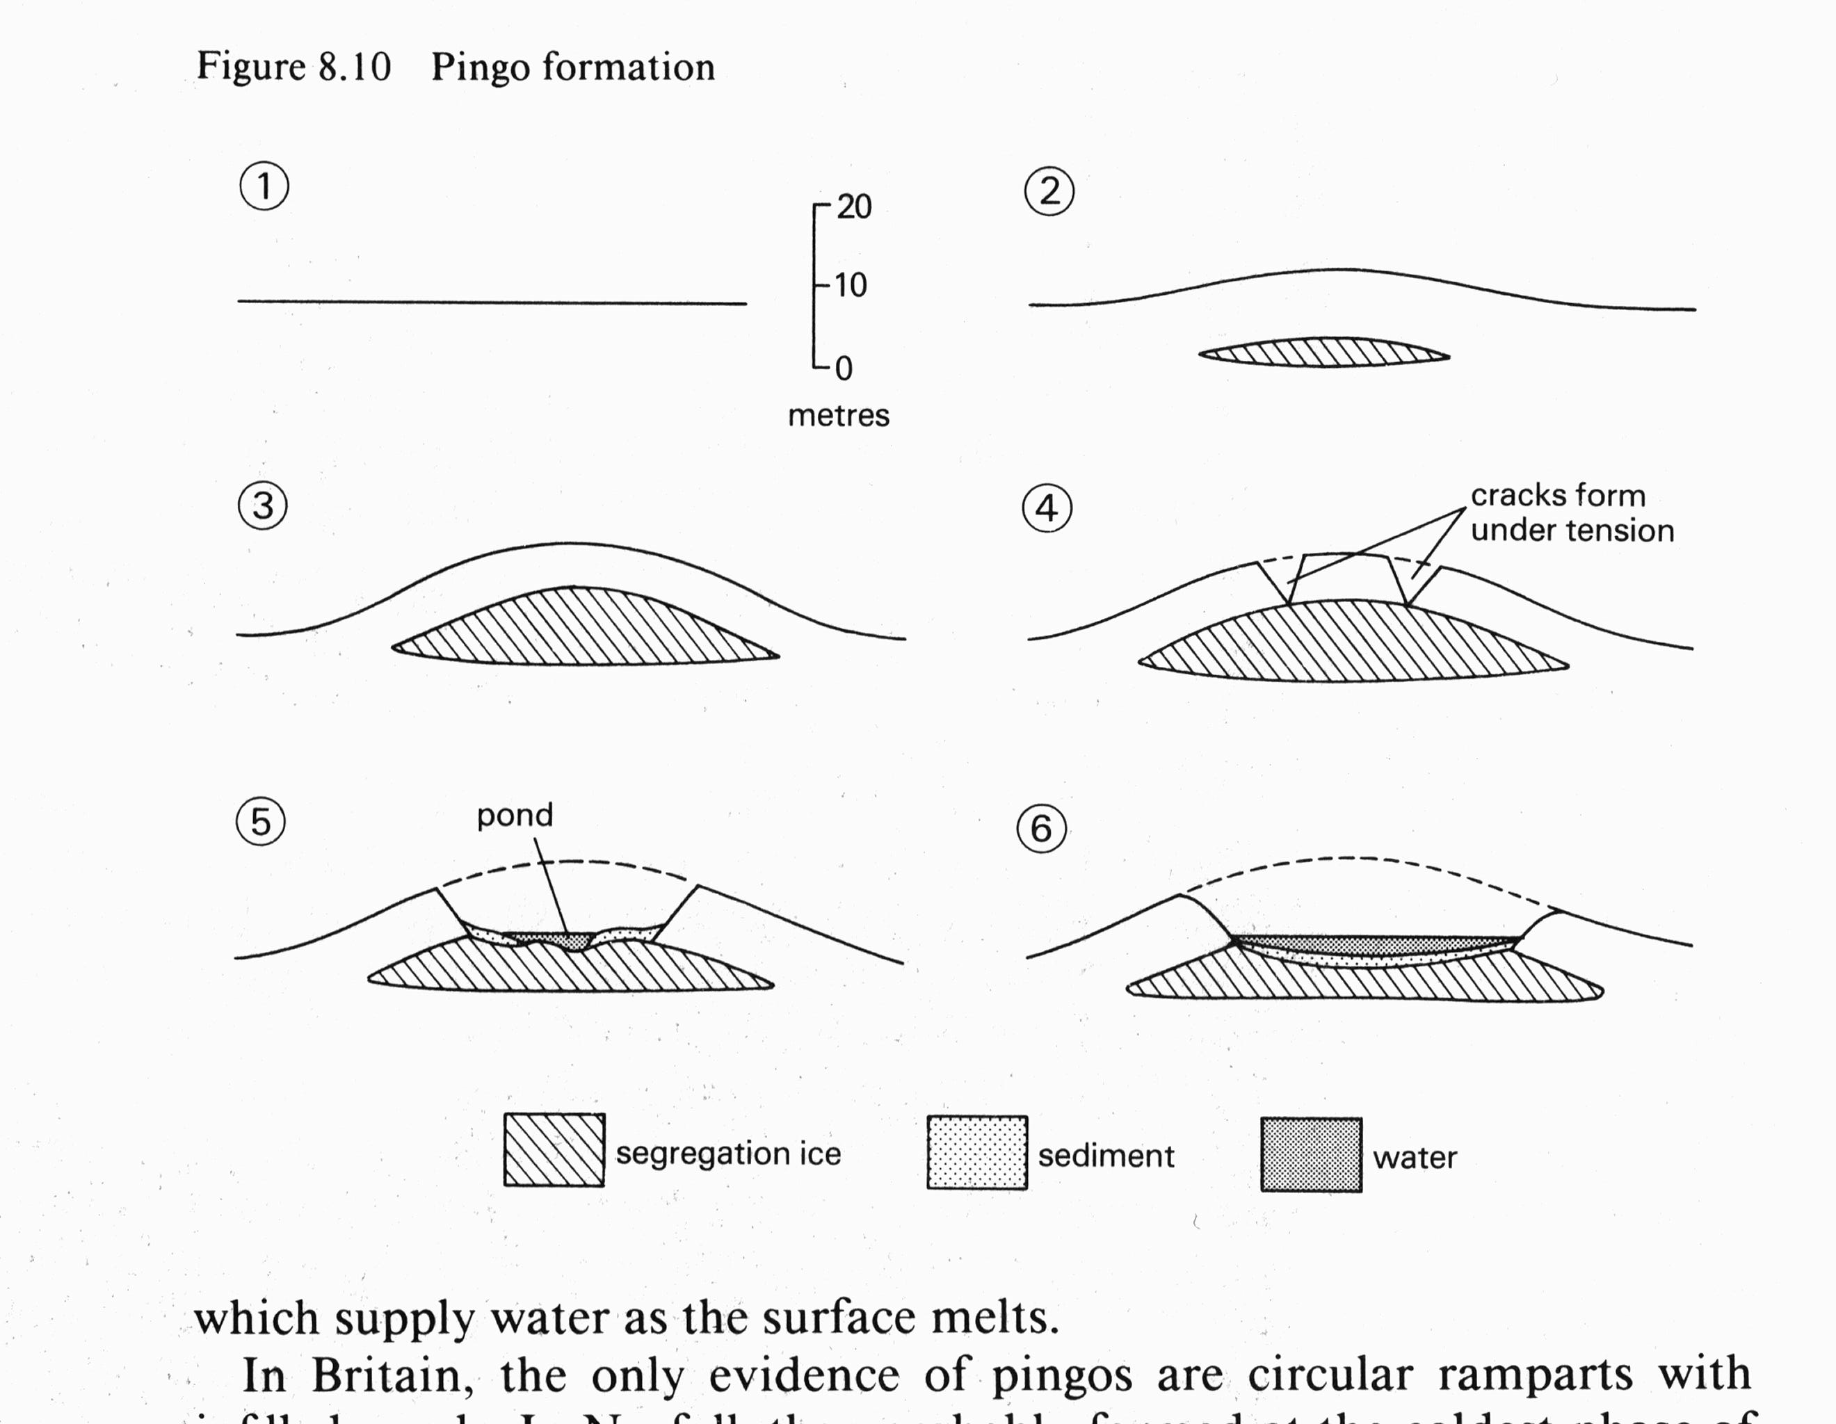
Pingos: Closed-system (MacKenzie type)
Pingos: Open-system (East Greenland type)

