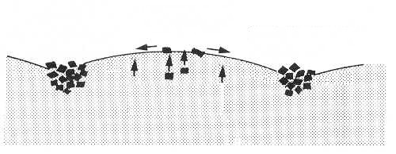
Stone sorting and stone polygons
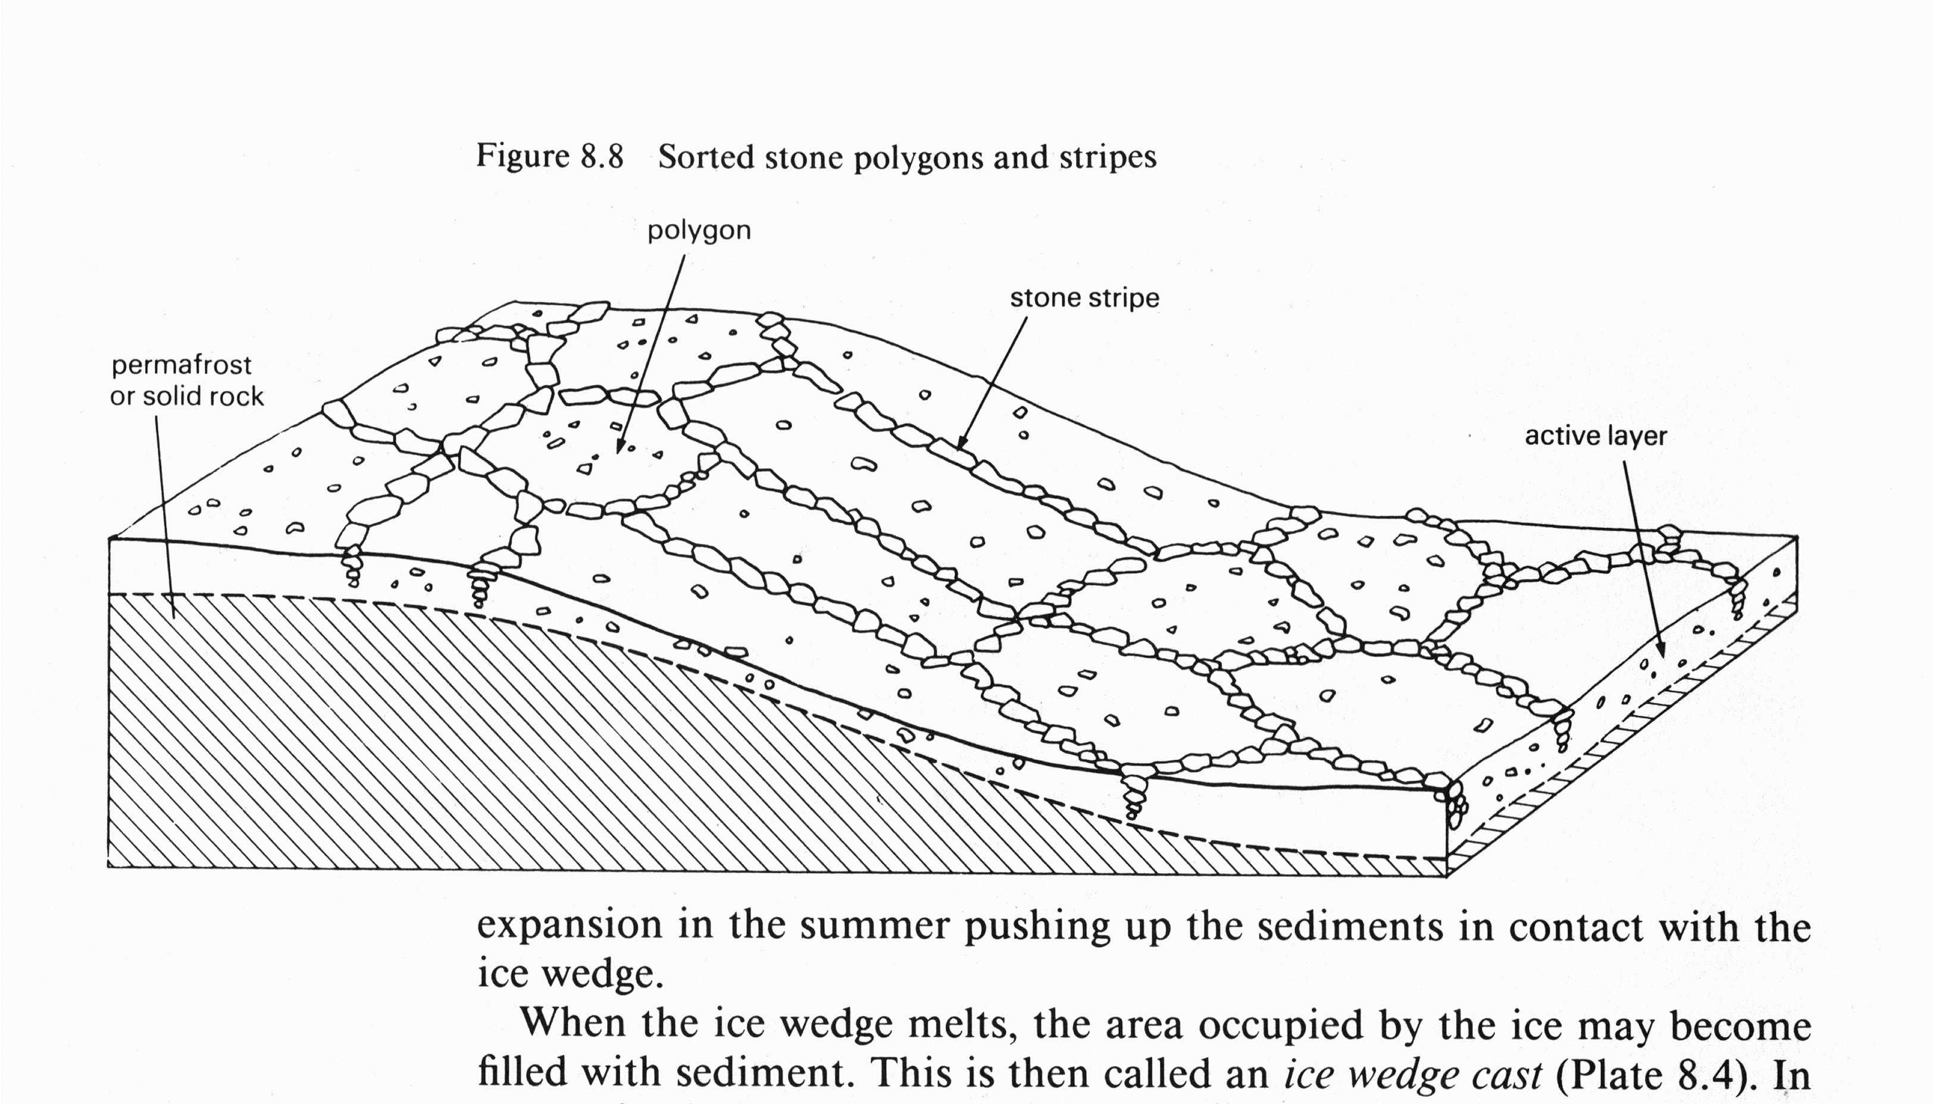
(slope > 5°)
(slope >5° but < 30°)
garland

