**Investigating Changing Places 2:**

***How important is tourism to Betws-y-Coed?***

**Methodology:**

You will have 3-4 hours in Betws-y-Coed on the last day. In your group you will need to plan the following data collection strategies that can be achieved in this time in order to attempt to address the investigation question:

1. **A service survey**.

*Rationale:* This will help you to determine which services are linked to tourism in some way and which are not – permitting an assessment of the relative importance of tourism to the village.

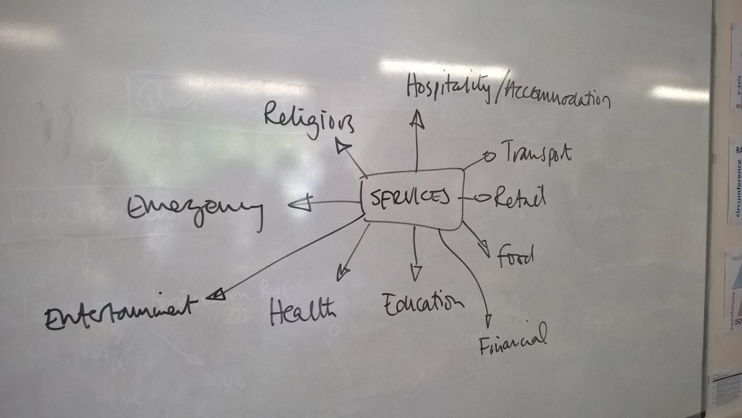*Data types:* This will largely be quantitative but should also include some qualitative data (e.g. photos, to show examples of tourist-related services and those that are not). Remember that ‘service’ is not a synonym for ‘shop’… so ensure you have a good idea of the range of different services, e.g.:

You will also need to determine how important tourism is to each service – it won’t just be a black/white decision – so how can you do this simply? In some cases you will need to determine this yourself, in others you may be able to ask the service provider…

There’s reference to independent shops in one of the secondary sources. Is this something you could investigate? How might this indicate the relative importance of tourism here?

Be aware also of services that might be there to support other parts of the economy, e.g. agriculture. And don’t forget that the local residents will need some services for their own needs…

*Equipment:* This could mapped – so as detailed a basemap as possible will be needed (remember: Bing maps to get a 1:25000 map, NOT GOOGLE)! Coding the results would be a sensible way to simplify the data if you’re going to map it, but be aware that summarising raw data can cause problems later. You could simply record this on a table for each service type and the degree to which tourism is important – though this would limit presentation methods. Camera/notebook.

1. **How different groups view the importance of tourism at Betws-y-Coed (using questionnaires)**.

*Rationale:* This will add another dimension to your investigation as it’s not reliant on your assumptions. By asking tourists, local residents and workers, you should get a good idea of how different people view the impacts of tourism. By asking tourists what they’re doing/spending etc., you can get some objective data to infer the impacts of tourism on the economy. By asking them where they’ve come from you can get an idea of ByC’s sphere of influence (important Geog concept) that can permit some interesting mapping and give some indication of how important ByC might be as a tourist detinmation.

*Data types:* As with Blaenau Ffestiniog, this is likely to be both quantitative and qualitative depending on the questions you ask. Make sure you have read the guidance on questionnaire design to avoid questions that are: leading, too open, too closed, unclear, inappropriate or offensive! Questions will differ for the three groups, but should include (as a minimum) some idea of:

* What tourists/visitors have come to ByC to do, how long they’re staying (if overnight – what type of accommodation), where they’ve come from and how much they spend. These are all critical in determining how important their visit is to the local economy.
* What local residents feel about the impacts of tourism: good/bad, and why.
* How much businesses are affected by / dependent on tourism…or are they really there to serve the local people?

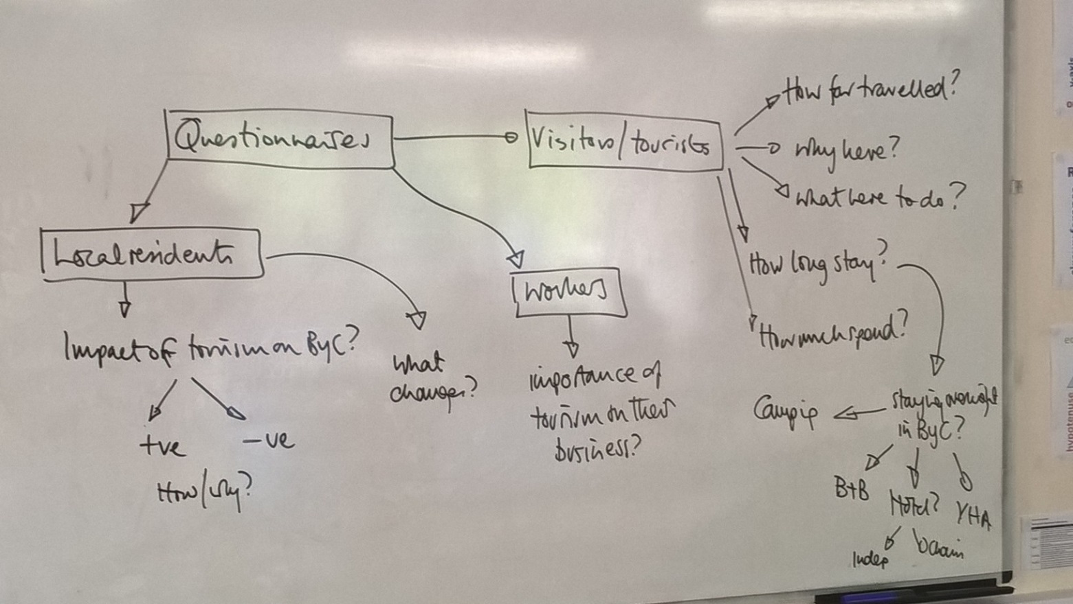E.g.

*Equipment:* The questionnaire and a recording sheet. The latter should be simple enough to be able to fill in quickly (preferably by someone other than the questioner) and allow each respondent’s answers to be identified/matched. This last part is absolutely vital as it’s the only way you can analyse and compare the views of the different groups. Therefore a simple tally chart will not be good enough.